PROPOSAL OUTLINE

Title of the proposal
ESCULAPUS - An integrated environment for worldwide secure exchange of healthcare information.

General objectives

Implement an open-source platform based on international standards to enable the integration of health care applications, such as: patient care, decision support, tele-health and e-learning.

To demonstrate the advantage for health care professionals and patients by the implementation of significant case scenarios.

European Programme addressed: @LIS –e-Health

Brief description
Development of an integrated environment to integrate patient care, decision support and e-learning at the point of care. The main objective is the construction of the models, standards and interfaces to provide the integration across the different applications addressing the need for privacy and security. A turn-key demo package to demonstrate the interoperability between applications will be constructed.

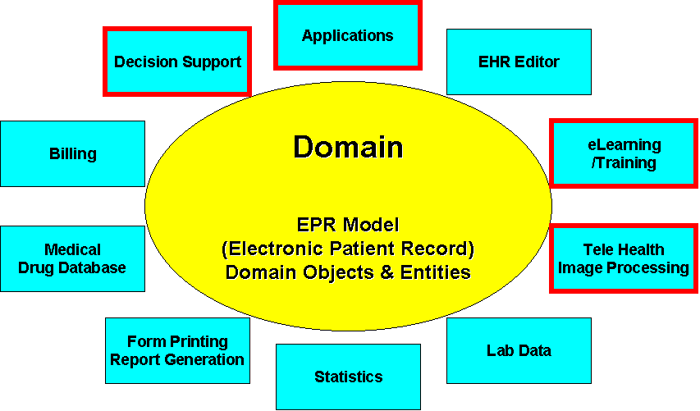

2nd Working Session

Innovation and benefits

Which are the innovative aspects of the proposal?
Innovation can be in the form of novel products/services/applications. It can range from the development of novel techniques / systems / environments to the integration of new generation technologies in original ways. It can include development of novel business processes, new organisational practices or, more generally, novel forms of interaction between people and information, whether at work or in daily life.

Definition and implementation of the XML Healthcare standards to exchange health care information between different applications.
Dissemination of the information models of the EHR (Electronic Health Record) that will allow for the information exchange.
Dissemination of the use cases describing the interoperability scenarios.
Dissemination of software components that incorporate the domain knowledge and allow for the interoperability.

Specific benefits of the actions for the European Union and Latin America
Why the proposed project should be carried out at European & Latin America level instead of at national level? For example, if there is a need to create a critical mass in human or financial terms, or whether the project will bring together complementary expertise existing in different organisations...

This project aims to integrate several international initiatives currently active in defining the standards for health care information exchange, such as CEN 251 the OPEN EHR, HL7,
The contribution of this project is that it goes one step further by implementing a demo scenario where these standards can be validated and tested in real life situations.
This project is useful for situations where there is the need to integrate different applications in order to provide better patient care. For tourists and out of area missions this can be especially interesting.

Adequacy to the objectives to European Programmes

Identify the proposal in a specific European programme
As RTD project or demonstration or support measure

This project has close links with the work of CEN TC 251 – WG 1 – Information Models regarding the conceptual aspects.
On the implementation side this project has important links with the SPIRIT project (www.euspirit.org) in special with the PICNIC project (http://www.medcom.dk/picnic/default.htm).
Although not an European initiative the Open EHR - Open Electronic Health Record (www.openehr.org) has also a strong link with this project.

Other possible funding programmes

Colleagues from Europe please fill this part.

3rd Working Session

Technical details of the proposal

How the proposal concepts will be developed?

Project Management Tools
Rational Unified Process
Web dissemination

What type of technology will be used?
Software components (EJB, Corba)
Standards (XML for healthcare, CORBAmed, SOAP, HL7, CEN 251, Open HER, ISO TC 251, DICOM)
LiNUX,
Design Patterns, Architectural Patterns,
Open SSL,
Multi-layered architecture

Technological challenges
Standards Maturity
Interoperability In the health care scenario
Consensus on the Information models for the EHR (Electronic Health Record)

Organisational, procedural and human factors
Are social issues addressed?. How will the proposal contribute to meeting the social objectives of the Community such as: improving the quality of life and education and/or how it will contribute to improving employment, etc.

The interoperability between different applications will allow, for example, for offering expertise to out of reach areas. This leads to better quality of care and less cost for heath care.
In addition to that it is expected that the software components provided by this project will have a positive factor in the market, stimulating the production of health care applications that incorporate the standards to interoperate.

Who knows the involved technology and how to access it?

The project partners have isolated experiences in developing health care applications for different scenarios, such as image processing, electronic health records, primary care systems, decision support tools and e-learning methodologies.
There is also experience in developing and deploying IT for healthcare in large national projects such as the Brazilian National Health Care Project. Most of the partners are very active in the international standards group related to this project such as GEHR, OMG Health Care Task Force and CEN and ISO.

We have not discussed this so please feel free to change, add…

What are the main work packages?
•WP0: Project Management
WP1: Vision, Requirements, and Specification
• WP2: Use Cases Definition
• WP3: Analysis and Design
• WP4: Implementation
• WP5: Verification and Validation
• WP6: Demonstration
• WP8: Legal, Ethical and Security

What are the main risks?
Legal and ethical issues of managing sharing patient data
Lack or too many standards
Interdisciplinarity (also an opportunity)
Cultural and language differences

4th Working Session

Consortium structure

Coordination – Europe:
Insula-International scientific council for island development | Anamarija Margan | anamarija.margan@ri.tel.hr

Technical Coordination
SNIS – Ministry of Health Brazil | Beatriz de Faria Leão | Beatriz.leao@saude.gov.br

Definition of the role of each partner, and the benefit of the action for each partner
Institution | Name | E-mail | Role
Brasilia Univeristy | Wagner Teixeira da Silva | wagner@unb.br | Use Cases Definition of Decision support integration, design, implementation, verification and validation of the Decision support interfaces. Dissemination of models, use cases and code.
Centro de Desarrollo Informático para la Salud Pública de Cuba, CEDISAP | Alfredo Rodríguez Díaz | alfredo@cedisap.slp.cu | Use cases definition of the Data mining interfaces, design, implementation verification and validation of the data mining interfaces. Dissemination of models, use cases and code.
Hypercom do Brasil | Manoel Lemos | mlemos@hypercom.com  manoel@lemos.net | Use Cases Definition, Design and Implementation. Validation and Verification of the Interfaces. Dissemination of EHR model, use cases and implementation.
IMBIE University of Bonn | Gustav Quade | quade@uni-bonn.de | Use Cases Definition for the Tele Health Integration, Retrieval and Coordinator of the Legal, Ethical and Security Working package. Dissemination of the documents of the WP.  Coordinator of the Validation and Verification Working Package. Dissemination of the Results of the Validation and Verification WP.
Insula-International scientific council for island development | Anamarija Margan | anamarija.margan@ri.tel.hr | Project Coordinator, Project Management, Coordinator of the Demonstration WP. Use cases definition of the Tele-Health interfaces.
INTEC (National University of Litoral, CONICET) | Gabriela Henning | ghenning@intec.unl.edu.ar | Coordinator of the WP of Verification and Validation. Participation in the design and implementation and in the use cases definition as a facilitator in the Unified Process (especially for the decision support and e-learning components). Dissemination of the Use Cases and Validation Packages.
National School of Public Health / FIOCRUZ | Sérgio Pacheco de Oliveira | spacheco@ensp.fiocruz.br | Use Cases Definition of the EHR information model. Design and Implementation. Dissemination of EHR model, use cases and implementation.
National Technical University of Athens | Vasiliki Karounou | karounou@netmode.ntua.gr | Responsible for the Project Management Tools. Use Cases definition for the essential data set for traffic accidents. Implementation of the interfaces for the traffic accident. Demonstration and Dissemination.
Professional Solutions | Carmen Alicia Aquino | carmenaquino@cantv.net  carmenaliciaa@cantv.net | Participation in the Project Management, Use cases definition, Design and Implementation.
SNIS – Ministry of Health Brazil | Beatriz de Faria Leão | Beatriz.leao@saude.gov.br | Technical coordination, Coordinator of the Vision and Specification WP. Information model for the EHR – Electronic Health Record, Use Cases Definition, Design and Implementation. Dissemination of EHR model, use cases and implementation.
TU Ilmenau  ResMedicinae OSP | Christian Heller | Christian.Heller@tu-ilmenau.de  Christian.heller@tuxtax.de | Coordinator of the Design and Implementation Working Package. Development of the project web site and dissemination of the software components, documents and XML DTDs and schemas referring to the design and implementation.
UFRGS | Rosa Vicari | rosa@inf.ufrgs.br | Use cases definition of the e-learning interfaces. Design and implementation of the e-learning Interfaces. Dissemination of the use cases and implementation. Demonstration of the e-learning component.
Universidade de São Paulo | Evandro Eduardo Seron Ruiz and  Adriano de Jesus Holanda | evandro@usp.br  aholanda@dfm.ffclrp.usp.br | Use cases definition of the medical images interfaces. Design and implementation of the use cases for the images integration. Responsible for the dissemination WP.

Profiles of the partners required to complete consortia

The PICNIC Project has a lot to do with ours. Maybe they could also be with us.
DLR – (Gustav – would you fill this for us?)

5th Working Session

Future work

Provision of a schedule indicating the actions, actors and deadlines required to complete the writing of the proposal

Action | Actor | Deadline

