Grant Application Form
EUROPEAN COMMISSION
@LIS Demonstration Projects
Budget Line B7-311
Name of the Applicant: TU ILMENAU
Title of the project: AESCULAPIUS
– An Integrated Environment for worldwide secure Exchange of Healthcare Information, based on Open Source Software –

Dossier No
(for Commission use only)

The Applicant

Identity
Full legal name (business name): | Technische Universität Ilmenau
Acronym (where applicable): | TU Ilmenau
Legal status: | governmental
VAT registration number  (where applicable): | -
Official street address: | Max-Planck-Ring 14
City: | 98693 ILMENAU
Country: | Germany
Contact person: | Prof. Dr.-Ing. habil. Ilka Philippow  Dipl.-Ing. Christian Heller
Telephone n°: | +49-3677-69-1230
Fax n°: | +49-3677-69-1220
E-mail address: | christian.heller@tu-ilmenau.de

Bank details
Account name: | Staatskasse Thueringen, Technische Universität Ilmenau
Bank account no: | 820 015 00
Bank code: | 820 000 00
SWIFT code: | -
REFERENCE: | TUI-1581-22320890
Bank name: | Deutsche Bundesbank Filiale Erfurt
Bank address: | Max-Reger-Str. 14, 99096 Erfurt, Germany
Name(s) of signatory(ies): | Position(s) of signatory(ies):
Dr. Bernhard Haupt | Kanzler

Capacity to manage and implement projects
In 2001 TU Ilmenau obtained about 18 million Euro for research projects from external resources, comprising 3.2 million Euro from the industry, 6 million Euro from the Federal Government as well as 6 million Euro from the State Government of Thuringia and 0,7 million Euro from the EC. There are about 400 external supported research projects every year with approx. 300 scientific employees.

The Institute for Theoretical and Technical Informatics (Prof. Dr.-Ing. habil. Ilka Philippow, Dipl.-Ing. Christian Heller) is currently involved in the following projects:
- Design Methodology for Software Architectures for System Families; ZT Siemens AG, München; 03/2000-12/2002
- Using Domain-Engineering Techniques for the Development of Object-Oriented Systems with access to Host-based Legacy Systems in Insurance Business; Finanzdata GmbH, Gotha, HUK Coburg, funded by TMWFK; 06/2001-09/2003
- Intelligent Agent Architecture for e-business and Multimedia Product Information Systems; Project with Syscon GmbH, Sömmerda; funded by TMWFK; 08/2001-07/2003
- Migrating existing Software Systems into a Component Architecture; Siemens Dematic AG, Konstanz; 03/2002-02/2004

Its employees have collected plenty of experiences in nearly all kinds of software systems, in practice. Cooperation with industry has brought the requirement of future-proof application modelling to keep systems extensible in the future.
Prof. Dr.-Ing. habil. Ilka Philippow has been a referee for project evaluation within the
5th EC-Framework programme.

The Applicant TU Ilmenau successfully cordinates several European projects (see following table) or collaborates within such projects. So the scientists and administration is familiar with the rules and conditions.
The table shows a detailed description of the projects related to Information Society issues implemented by a consortium managed (or coordinated) by the Applicant over the past five years:
Project title: | DEMINE - „Surface Penetrating Radar Detector for Humanitarian Demining“  Contract No. 29902
Geographical location of the partners and/or of the target groups: | Europe
Funding sources: | EC, 4th Framework Programme (ESPRIT)
Budget: | Total: 1.631.000 Euro  TU Ilmenau: 199.999 Euro
Main achievements: | Humanitarian Demining; system and sensor development
Role (leader, partner) and level of involvement in implementing the project (indicate % of participation): | Co-ordinator; 100 %

Project title: | DEMAND - „Technologies and Data Fusion Algorithms for Antipersonnel Landmine Detection“  Contract IST-2000-25351
Geographical location of the partners and/or of the target groups: | Europe
Funding sources: | EC, 5th Framework Programme
Budget: | Total costs: 3.701.800 Euro  TU Ilmenau: 212.000 Euro
Main achievements: | Humanitarian Demining; development and test till prototype
Role (leader, partner) and level of involvement in implementing the project (indicate % of participation): | Co-ordinator; 100 %

Project title: | „MFD - Magneto Fluid Dynamics Action P6“
Geographical location of the partners and/or of the target groups: | Europe
Funding sources: | COST-Framework (European Co-operation in the Field of Scientific and Technical Research)
Budget: | approx. 50.000 Euro
Main achievements: | Research
Role (leader, partner) and level of involvement in implementing the project (indicate % of participation): | Co-ordinator; 100 %

Project title: | INTAS-1001 „Graph Colourings“  (97-1001)
Geographical location of the partners and/or of the target groups: | Europe, States of the former Soviet Union
Funding sources: | INTAS-Projects (Internat. Association for the Promotion of Cooperation with Scientists form the New Independent States of the former Soviet Union)
Budget: | Total: 30.000 Euro  TU Ilmenau: 4.000 Euro
Main achievements: | Research
Role (leader, partner) and level of involvement in implementing the project (indicate % of participation): | Co-ordinator; 100%

Resources
Detailed description of the various resources at the disposal of the applicant (maximum 3 pages):

The overall number of TU Ilmenau staff is at present 1850 employees, the staff funded from outside sources is about 474. Parting from this figures the total numbers of teaching professors is about 107 including acting professors and 350 of scientific academic staff. The total number of students at the university has been coming up very fast in the last years from 2.600 students in 1992 over 3.500 in the 1997 and is at present about 7.200.

The TU Ilmenau has stable and sufficient financial sources to ensure the continuity of their organisation throughout the project and to play a part in financing it. In 2001 the total budget of TU Ilmenau amounted to 91,1 Mio. Euro, from there 78,2 % financed by the State Government of Thüringen. The university obtained about 19 million Euro corresponding to 21,8 % from outside project resources comprising 3,22 million Euro from the industry (includes projects with more than 500 enterprises worldwide), 6,65 million Euro from the Federal Government as well as 7 million Euro from the State Government of Thüringen and 3,22 million Euro received from other industry founds, 2,3 million Euro from the “German Research Society (Deutsche Forschungsgemeinschaft)”. From European founds the university obtained 0,72 million Euro, 0,8 % of the total budget. There are 400 external projects with 300 scientific employees founded from external resources each year.

Overview budget of TU Ilmenau in 2001 according to the financing sources (all figures in million Euro):
Fig. 1: Budget of Applicant TU Ilmenau

The following Annex Thüringer Ministerium für Wissenschaft, Forschung und Kunst, part Technische Universität Ilmenau shows the official and detailed figgers concerning:
- a description of the various and other relevant resources at the disposal of the TU Ilmenau and the annual income over the past three years,
- the number of full-time and part-time staff by category

The complete budget of the TU Ilmenau can be downloaded under: <http://www.thueringen.de/de/tfm/haushalt/20012002/index.html> for further information.

- the annual income over the past three years, mentioning for each year the name of the main financial contributors and the proportions of annual income contributed by them:
- 2001 ca. 74,8 Mio. Euro (of which 60,8 Mio. Euro contributed by TMWFK)
- 2000 ca. 75,8 Mio. Euro (of which 62,5 Mio. Euro contributed by TMWFK)
- 1999 ca. 81,6 Mio. Euro (of which 64,3 Mio. Euro contributed by TMWFK)
- the number of permanent and part-time staff by category (Year 2001)
- Total staff: 1814
- of which scientific: 1046
- of which technical: 768
- major equipment and other physical means
- Computing center with computer pools running various operating systems
- Working places with personal computers and workstations
- Scientific Network Infrastructure; Network Connection and Bandwidth: Deutsches Forschungsnetz (DFN); http://www.dfn.de; 2,4 Gbit/s; 30-50 Mbit
- in general: modern University of Technology with equipment at the state of art for all departments.

Other applications submitted to European institutions or EU member states

Information on Community or EU Member State grants, procurement contracts or loans obtained directly or indirectly during the last three years
Title of operation | EC budget line, EDF or other source | Amount (EUR) | Duration
5th Framework Programm for Research and Technical Development (FP5): WIREGONE  „Wire-less Monitoring online of Strain and Temperature“, Prof. Dr. Werner Buff |  | 257.200 € | 2001 – 2003
5th Framework Programm for Research and Technical Development (FP5): SMAC  „Smart Control of Waste Water Systems“, Prof. Dr. Horst Puta |  | 198.000 € | 2001 – 2004
5th Framework Programm for Research and Technical Development (FP5): CASC  „Computational Aspects of Statistical Confidentiality“, Prof. Dr. Karl Luhn |  | 56.500 € | 2001 – 2003
5th Framework Programm for Research and Technical Development (FP5): AGENTLINK-II  „Continuation of a Network of Excellence in Agent-based Computing“, Prof. Dr. Stefan Kirn |  | 19.000 € | 2001 – 2003
5th Framework Programm for Research and Technical Development (FP5): EUTIST-IMV IMTEX  „Image Guided Distortion Measurement for a Weft Straightening Machine“, PD Dr. Karl-Heinz Franke |  | 73.200 € | 2000 – 2002
5th Framework Programm for Research and Technical Development (FP5): HIDEF  „High Definition Video Extensometer“, Prof. Dr. Gerhard Linß |  | 360.500 € | 1999 – 2002
5th Framework Programm for Research and Technical Development (FP5): SCENET  „European Network on Superconductivity, Node Simulation and Design“, Prof. Dr. Hermann Uhlmann |  | 14.300 € | 1999 – 2001
INTAS-Projects (Internat. Association for the Promotion of Cooperation with Scientists form the New Independent States of the former Soviet Union): INTAS-731  „Ultra Low Noise Superconducting Devices for High Frequency Detection“, Prof. Dr. Hermann Uhlmann |  | 6.100 € | 1998 – 2001

Information on other grant applications to European institutions in the current year:
Title of project / EC budget line, EDF or other source | Amount (EUR)
FLASIC - „Flash Lamp Supported Deposition of 3C-SiC Films“  5th Framework Programm for Research and Technical Development (FP5): | 243.000 €  2002 – 2005
5th Framework Programm for Research and Technical Development (FP5): FULCE  „Functional Liquid Crystal Elastomers“ | 199.930 €  2002 – 2006
5th Framework Programm for Research and Technical Development (FP5): REASON  „Research and Training Action for System on Chip Design“ | 191.600 €  2002 – 2004
5th Framework Programm for Research and Technical Development (FP5): AGENTCITIES.NET  „Testbed for a Worldwide Agent Network“ | 12.500 €  2002 – 2003
5th Framework Programm for Research and Technical Development (FP5): SCENET-2  „European Network for Superconductivity“ | 3.200 €  2002 – 2006
INTAS-686 - „Development of Ultra-low-noise Superconducting Devices for High Frequency Detection“  INTAS-Projects (Internat. Association for the Promotion of Cooperation with Scientists form the New Independent States of the former Soviet Union) | 6.000 €  2002 – 2004
E-LEN - “Network of e-Learning Centers”, MINERVA SOCRATES-Project | 40.000 €  2002 – 2004

Partners of the applicant participating in the project
The Applicant and the Partners have signed a Memorandum of Understanding as per the Guidelines for Applicants. The copies of the M.o.U.'s are certified by the Applicant and annexed to this project proposal (according to the @LIS-information desk). The originals are kept at the Co-ordinators office.
Table 1/2
 | Full legal name (Business name) | Short name | Country | Legal Status | Official address | Contact person for the proposal
Applicant | Technische Universität Ilmenau, University of Technology | TU ILMENAU / TUI | Germany | Governmental | Max-Planck-Ring 14  98693 Ilmenau  PF 100565  98684 Ilmenau | Prof. Dr. habil. Ilka Philippow;  Dipl.-Ing. Christian Heller
Partner 1 | Universidad Nacional del Litoral (National University of Litoral) | UNL | Argentina | Governmental | Bv. Pellegrini 2750  3000 - Santa Fe | Prof. Dr. Gabriela P. Henning
Partner 2 | Institut of Medical Biometry, Informatics and Epidemiology, Universität Bonn (University of Bonn) | IMBIE | Germany | Governmental | Sigmund-Freud-Str. 25  53127 Bonn  Regina-Pacis-Weg 3  53012 Bonn | Dr. Gustav Wilhelm Quade
Partner 3 | Fundacao da Faculdade de Ciencias, Universidade de Lisboa (University of Lisbon) | UdL | Portugal | Governmental | Edifício C7  1º Piso  Campo Grande  1749-016 Lisboa | Prof. Helder Manuel Ferreira Coelho
Partner 4 | Instituto de Desarrollo y Diseño, Facultad Regional Santa Fe, Universidad Tecnologica Nacional | CONICET | Argentina | Governmental | Avellaneda 3657  3000 Santa Fe  Lavaise 610  3000 Santa Fe | Prof. Dr. Horacio Pascual Leone
Partner 5 | Onega Ltd. | Onega | Great Britain | Private | Caxton Street Studios  Caxton Street North  Canning Town  London E16 1JL  England | Luis Echezuria
Partner 6 | Instituto de Informatica, Universidade Federal do Rio Grande do Sul | UFRGS | Brazil | Governmental | C.P. 15064  Av. Bento Gonçalves 9500  91501-970 Porto Alegre  RS | Prof. Rosa Maria Vicari
Partner 7 | Fundação Oswaldo Cruz - Escola Nacional de Saúde Pública (Oswaldo Cruz Foundation - National School of Public Health) | FIOCRUZ - ENSP | Brazil | Non-profit | Manguinhos  sala 727  Rua Leopoldo Bulhões 1480  21041-210 Rio de Janeiro  RJ | Prof. Sergio Pacheco de Oliveira
Partner 8 | Synetics Diagnostics International C.A. | Synetics | Venezuela | Private | Local B  Boleita Norte  Edif. Alessandro Piso 2  Calle E Norte  Caracas 1071 | Francisco Gonzalez Arias
Partner 9 | GRNET S.A.  Greek Research & Technology Network | GRNET | Greece | Non-profit | 56, Mesogion Av.  11527 Athens | Vasiliki Karounou
Partner 10 | Departamento de Ciência da Computacao CIC/IE - Universidade de Brasilia (University of Brasilia - Computer Science Department) | UnB | Brazil | Governmental | ICC ASS 504/11  Campus Darcy Ribeiro  Asa Norte  P.O. Box 4466  70919-970 Brasilia  DF | Prof. Dr. Wagner Teixeira da Silva;  Prof. Dr. Marcelo Ladeira

Table 2/2
 | Short name (in this proposal) | E-mail address (Contact person) | Phone | Fax | Number of staff on payroll (full-/ part-time) | History of cooperation with the applicant | Role and involvement in preparing the proposed project | Role and involvement in implementing the proposed project
Applicant | TU ILMENAU/ TUI | christian.heller@tu-ilmenau.de | +49-3677-69-1230 | +49-3677-69-1220 | 1814 | - | preparing | Coordinator
Partner 1 | UNL | ghenning@intec.unl.edu.ar | ghenning@intec.unl.edu.ar |  |  | - | contributed | Partner
Partner 2 | IMBIE | quade@uni-bonn.de | quade@uni-bonn.de |  |  | - | contributed | Partner
Partner 3 | UdL | hcoelho@di.fc.ul.pt | hcoelho@di.fc.ul.pt |  |  | - | contributed | Partner
Partner 4 | CONICET | hleone@ceride.gov.ar | hleone@ceride.gov.ar |  |  | - | contributed | Partner
Partner 5 | Onega | luis.echezuria@onega.net | luis.echezuria@onega.net |  |  | - | contributed | Partner
Partner 6 | UFRGS | rosa@inf.ufrgs.br | rosa@inf.ufrgs.br |  |  | - | contributed | Partner
Partner 7 | FIOCRUZ - ENSP | spacheco@ensp.fiocruz.br | spacheco@ensp.fiocruz.br |  |  | - | contributed | Partner
Partner 8 | Synetics | syneticsuk@syneticsint.com | syneticsuk@syneticsint.com |  |  | - | contributed | Partner
Partner 9 | GRNET | karounou@netmode.ntua.gr | +30-107474-274 | +30-107474-490 |  | - | contributed | Partner
Partner 10 | UnB | mladeira@unb.br | mladeira@unb.br |  |  | - | contributed | Partner

Project Description

Title
Aesculapius
– An Integrated Environment for worldwide secure Exchange of Healthcare Information, based on Open Source Software –

Acronym
AESCULAPIUS

Summary
Historically, Latin American Health Departments have not used or developed IT as a strategic asset in delivering and managing healthcare. While there were good, usually local, IT initiatives sponsored by enthusiastic visionaries, these were outweighed by the overall lack of funding and high development costs, often leading to a dependency on the technology providers.
AESCULAPIUS’ principal aim is to redress the balance and Implement an Open-Source Electronic Health Record Framework based on international standards to enable the integration of health care applications, such as: patient care, decision support, tele-health and e-Learning. To demonstrate the advantage for health care professionals and patients alike, by the implementation of significant case scenarios.

Objectives of the project
New technology offers great possibilities for improving both the quality and the confidentiality of patient information stored within the Health Service. This is contrary to the perceived view that increasing computerisation of information can only undermine privacy and confidentiality.
The Electronic Patient Record (EPR) and Electronic Health Record (EHR), through digital capture of clinical information at the ‘frontline’, will increase the quality and availability of information that the Health Service holds.
At the same time, through the use of a Unique Patient Identifier (such as a encrypted National Health Number), the information can be automatically ‘pseudoanonymised’ before flowing into central databases for management and research uses.
As a result, high quality, timely and linkable anonymous data will be available, allowing sophisticated analyses without any need for disclosure of identifiable confidential patient information.
However, while the benefits of such system are plain to see, the cost of implementing such a sophisticated system comes at a high price, which is beyond most Latin American Countries. Which goes to the heart of the purpose of this project, “To develop an Open Source Electronic Patient Record System”.
Bellow are further details of objective of the project.
The general objective of the project is to:
- Develop an integrated environment for worldwide secure exchange of healthcare information
- Provide users with a free, stable, secure, platform-independent, extensible healthcare system
- Design, develop, install and maintain a Clinical Management Systems that brings together patient information across the continuum of care from the Mom’s pregnancy through the infant’s developmental care
- Deliver a software prototype ready to be used in practice
- Place primary focus on the usability and functionality of software, not only the creation of hundreds of theoretical documents
- Provide extensive documentation on how to use the software system
- Separate the project (software system development) into a number of subprojects (modules) and clearly assign responsibilities to each partner in the project
- Base any development activities (Source Code and Documentation) on Open Source Licenses
- Work cost-effectively by reusing as many Open Source resources as possible
- Share knowledge not only between Europe and Latin America but also with any other people living on "the poorer side of" the world, by applying Open Source Licenses
- The project is funded with tax money of European/Latin American citizens coming from the EU/LA ALIS program. As such, it is only fair to return ANY project achievements and results back to the public/commonality. To ensure this, ALL software developed within the AESCULAPIUS project will have to be put under an OSI-approved Open Source License. It is up to the Partner/Developer of a Module which Open Source License he/she chooses. Preferably, the GNU GPL should be used for any piece of software and the GNU FDL for any piece of documentation. In any case, the basic System and Domain Model Framework as well as the Healthcare Domain Model will be put under the GNU GPL License. This regulation also avoids the use of Software Patents
The specific objectives of the project are:
- Improve communication and co-operation within the multi-disciplinary care team
- Improve patient satisfaction and participation in care, since patients know what their plan of care is to be whilst in hospital, and when discharged
- Improve standards of documentation reduce risk for the organisation and conform to the standards of professional bodies
- Improve discharge planning and co-ordination leading to shorter inpatient spells and improved bed utilisation
- Improve adherence to guidelines for best practices, as care providers can see at a glance what care is to be delivered and when and can obtain financial benefits
- Provide an ongoing process for continually measuring and improving clinical care processes
- Implement mechanisms for guiding of patients to and from other health units
- Become the foundation for improving the quality of care, reducing costs and ultimately saving lives at the hospital
- Let resulting services conform to international/EU standards

Clinical purposes
Practices currently require a patient record system that can be used to:
- Assist in the clinical care of individual patients by:
- Assisting the author to structure his or her thoughts and make appropriate decisions;
- Acting as an aide memoire for the author during subsequent consultations;
- Making information available to others with access to the same record system who are involved in the care of the same patient;
- Providing information for inclusion in other documents (e.g. laboratory requests, referrals and medical reports);
- Storing information received from other parties or organisations (e.g. laboratory results and letters from specialists);
- Transfer the record to any Health Service practice with which the patient subsequently registers.
- Assist in the clinical care of the practice population by:
- Assessing the health needs of the practice population;
- Identifying target groups and enabling call and recall programmes;
- Monitoring the progress of health promotion initiatives;
- Providing patients with an opportunity to contribute to their records;
- Supporting medical audit.

Non-clinical purposes
Practices also need a patient record system that can be used to meet administrative, legal and contractual obligations by:
- Providing medico-legal evidence (e.g. to defend against claims of negligence or breach of service);
- Providing legal evidence in respect of claims by a patient against a third party (e.g. for injuries, occupational diseases and in respect of product liability);
- Meeting the requirements of specific legislation on subject access to personal data and medical records;
- Recording the preferences of patients in respect of access to and disclosure of information they have provided in confidence;
- Providing evidence of workload within a practice;
- Providing evidence of workload to Health Authorities (e.g. to support claims and bids for resources);
- To enable commissioning of community and secondary healthcare services;
- Monitoring the use of external resource usage (e.g. prescribing, laboratory requests and referrals).

Additional purposes
Some practices also currently require a patient record system that can be used:
- To interact with a decision support / expert-system
- To support teaching and continuing medical education
- To enable:
- Epidemiological monitoring
- Surveillance of possible adverse effects of drugs
- Clinical research

Electronic and Paper Records
Most of the purposes described above are generic. In other words, they apply to both paper and electronic records. A few, however, are not in that they are only possible in an electronic environment; and some purposes are more easily fulfilled in an electronic record than a paper one and vice versa.

Justification
- Improves the quality of care and ultimately saves lives at your hospital
- Reduces costs
- Improves communication and co-operation within the multi-disciplinary care team
- Improves patient satisfaction and participation in care, since patients know what their plan of care is to be whilst in hospital, and when discharged
- Improved standards of documentation reduce risk for the organisation and conform to the standards of professional bodies
- Improved discharge planning and co-ordination leads to shorter inpatient spells and improved bed utilisation
- Improves adherence to guidelines for best practices, as care providers can see at a glance what care is to be delivered and when and can obtain financial benefits
- Provides an ongoing process for continually measuring and improving clinical care processes
- Transparent System Architecture under an OSI-approved Open Source License as well as extensive documentation ensure secure handling of patient data
- Just like traffic infrastructure, a common Healthcare Information Infrastructure must be freely available and accessible for any user (citizen)

Detailed description of activities
A modern and dependable Health Service needs accurate and instantly accessible information and the benefits of new high-speed, high-capacity information and communications networks. Aesculapius is a strategy to ensure that the Health Service of Latin American countries exploit the full potential of these developing technologies in the drive to transform the delivery of health services, improve the health of the nation and the quality of patient care. Over time, the strategy will deliver:
- Lifelong Electronic Health Records for every person in the country
- Round-the-clock on-line access to patient records and support on best clinical practice, for all Health Service clinicians
- A National Electronic Library for Health to keep doctors and nurses, and other clinical professionals up to date with the latest clinical research and best practice at the time they need it
- Integrated care for patients through GPs, hospitals and community services sharing information across the Health Service information highway
- Fast and convenient public access to information, advice and care through online information services and telemedicine
- More effective use of Health Service resources by providing NHS planners and managers with the information they need.
The new information strategy for the Health Service will help:
- Doctors, nurses and other clinicians to deliver better care by providing up-to-the-minute details of a patient's clinical history and current treatment, and access to the latest clinical research and best practice
- Health service managers and planners to ensure the Health Service spends its budget in the most effective way and that all sectors of the Health Service are working to the standards of the best
- Patients to become more effectively involved in treatment decisions by providing accurate information about their clinical problems, and the public to stay fit and well by providing reliable health information.

Having the role of a scientific coordinator, the TU Ilmenau will be responsible for the overall System and Domain Design.
Single (technical) work packages (Modules) are distributed to each project partner to avoid clashes in software development. At the same time, easy and effective cooperation between project partners as well as between their single Modules (with Interfaces) will have to be assured. Since the technical coordinator is actively developing Open Source software for many years, this shouldn't be a problem.
The aim is to implement integrated care records services (ICRS) records, which are:
- Integrated across all health and social care settings;
- Designed around the patient, and not around individual institutions;
- Therefore able to support the implementation of care pathways as part of National Service Frameworks.

The major change proposed is to move away from the concept of a number of separate information systems based primarily around organisational structures to a situation in which professionals are provided access to the one integrated service. The services will include access to records and the functionality needed to support clinical practice. Implementation of these services will lead to a number of important outcomes for:
- Service users, where a modern IT-enabled Health Service will directly and visibly impact on how they interact with the care system and on their experience as consumers of care services
- Health and care professionals involved with direct patient and service user care, who will have safe, fast, modern IT to support them routinely in their work
- Managers, researchers and other professionals not involved in direct patient care to have ready access to high quality, confidential, information

The requirements for such a service will continue to develop, and there is therefore a need for local flexibility and tools, and for commitment from suppliers to provide enhancements as part of the service.
Integrated Care Record Service incorporates the Information for Health concepts of both the organisation-specific Electronic Patient Records and also the cradle-to-grave Electronic Health Record. The framework for Integrated Care Record Service is illustrated in the diagram below.

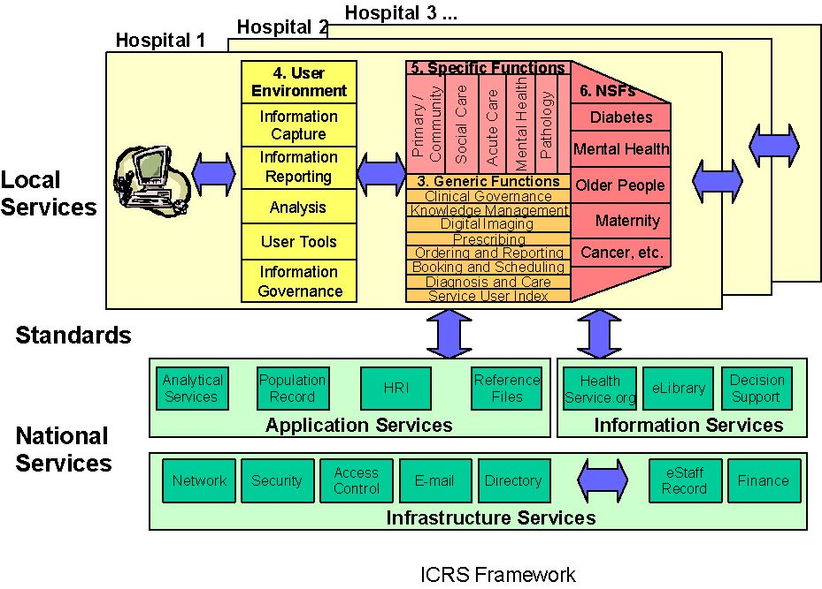
Fig. 2: Framework for Integrated Care Record Service

Approach
One of important features of the strategic programme for IT in the modern Health Service is the shift to more corporate, national approaches. For the purposes of health records, this means:
- There will be a national approach to procurement and implementation;
- The resulting services will need to conform to national standards;
- The resulting services must interoperate with emerging national services such as the Electronic Staff Record and the Health Records Infrastructure.

Conformance to international standards and use of national services is critical to enabling access to health records across the whole country, in support of emerging needs around National Service Frameworks and emergency care.
User Requirements
The Following describes the requirements for the integrated care record service. These requirements are structured so as to highlight the need for integration across health care sectors, and to highlight the need for flexibility and future development
There is a core set of generic functions, to operate across the whole health community. These include:
- The patient / service user index,
- Diagnosis,
- Treatment and care management,
- Booking and scheduling,
- Ordering and results reporting,
- Prescribing,
- Digital imaging,
- Access to knowledge (developing into decision support),
- Clinical governance and
- Operational service management.

It is important that such services are provided within a common user environment that enables the capture of information, the reporting and analysis of such information, and the provision of flexibility and user tools to support local development. It is vital that the services are based around a robust frame of Information Governance, addressing security, confidentiality and data quality issues.
There will remain some specific requirements, which relate to functions or data items relevant to a particular context of care.
Key to the National Health Plan is the work on specific delivery areas, particularly around those where National Service Frameworks are being developed. It is critical, however, that the information services to support NSFs are seen as part of the integrated whole, and not as a separate “silo” for a given condition type. This version of the specification includes the example for diabetes, where the requirements to support the care of patients is described with reference to the generic functions in the earlier sections. Future versions of this specification will include similar sub-sections for areas such as Coronary Heath Disease, Mental Health, Older People and Cancer.
One of the reasons for ICRS being described as a service rather than as a system is because the facilities will be critical to the running of the modern Health Service. Fast, reliable and efficient access is absolutely fundamental. The specification therefore describes both the delivery requirements and the service requirements for ICRS.
The delivery requirements include the project management, implementation, training and support arrangements. The service requirements section includes details about performance and availability, system resilience, accessibility and reliability and security. One of the features of the modern Health Service, and for services designed around the patient, will be the need to support access to information from a wide range of locations and through a wide range of media.

There's many Open Source Developer portals that can be used, such as:
- SourceForge.net  - Freshmeat.net | - Savannah.gnu.org  - Developer.Berlios.de

These portals offer all tools that are needed to effectively develop and test software, to communicate in a project, store source code and provide documentation:
- Summary  - Homepage  - Mailing List  - Forum  - CVS  - Bug Tracker | - Patches  - Documentation  - Project Tasks  - Support  - FTP Space  - Survey
Using these Portals and their tools can save a lot of time and initial costs to get the project running.
The ALIS program requires applicants to keep their project source code open and to put it under an OpenSource license such as GNU GPL. This effectively means that projects can also scoop from the whole pool of thousands of OpenSource projects, worldwide, to reuse their source code and any approved piece of software which again, results in a great amount of saved time and costs so that the project can early start to concentrate on its actual tasks.

The Institute of Theoretical and Technical Informatics in collaboration with the Institute for Biomedical Techniques and Medical Informatics, were able to collect plenty of experiences with complex software systems while working in several research as well as application projects over the past few years (see ). Since spring 2001, the Technical University of Ilmenau is also involved in the development of Medical Open Source Software, namely Res Medicinae:

Res Medicinae is to become a comprising software solution for use in Medicine which combines intuitive ease of use with the advantages of the Java platform. It uses latest technology adhering to common standards for medical software and will such be open to many other medical systems.
Res Medicinae is the attempt to overcome high pricing in the realm of Medical Information Systems and to provide users with a free, stable, secure, platform-independent, extensive system.
Res Medicinae is and will be free in every meaning. Its contributors enjoy working together communicating over mailing lists and are encouraged by the idea of sharing their knowledge with those people living on "the poorer side of" the world.

A lot of initial work has already been done preparing for this project. First steps towards a Medical Information System have been taken by creating modules for medical documentation, form printing/report generation and data administration. All resources of this and other projects are waiting to be reused and extended! Find other projects and resources at:
http://resmedicinae.sourceforge.net/doc/description/index.html

Because of the application of very fast Open Source Software Development Processes, the project can be expected to deliver first practical results within only a few weeks/months:

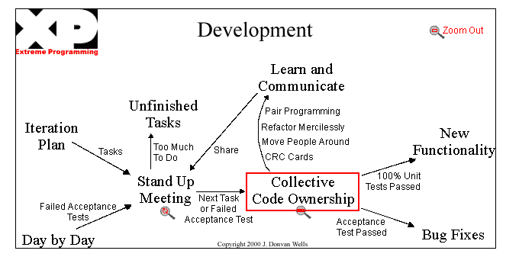
Fig. 3: Strategy for Open source projects (http://www.extremeprogramming.org)

Standards are critical to enabling the exchange of information, both locally and nationally. In the context of this specification, there is a wide range of standard to be considered. The following sub-sections are included here:
- Information governance - including confidentiality, security and data quality
- Terminology and Classification - SNOMED CT, ICD-10, OPCS-4, etc.
- Clinical Communications - HL7 version 3, DICOM and ENV 13606
- XML Schemas, HTML etc.
- Datasets
- Training and Service Management
- OpenEHR/GEHR/CENTTC251/ISO215
- HDTF/COBRAmed
- DICOM

Description of the structure of the project
The project is divided into a series of workpackages and a Workpackage Leader and Project Team has been assigned to take responsibility for each workpackage. A separate project initiation document will be prepared for each workpackage. The workpackage leaders have been selected based on their expertise in activities within each of the workpackages. They will be responsible to the Project Manager for the execution of the workpackage.

Figure: Structure of project AESCULAPIUS

List of workpackages: |  | Leader + involved partners
WP1 | Project Management | TU Ilmenau, Onega
WP2 | Vision, Requirements and Specification | ALL
WP3 | General Framework | TU Ilmenau
WP4 | Electronic Health Record (Main Module) | TU Ilmenau, Onega, Synetics, Bonn, GRNET
WP5 | Drug Information Database/Connecting Clinics | National University of Litoral, University of Santa Fe
WP6 | Patient and Resources Scheduling | Universidade de Lisboa
WP7 | Medical Terminology Service | University of Bonn
WP8 | Decision Support, Data Mining | UFRGS, UnB
WP9 | Traffic Accident Care | GRNET S.A.
WP10 | Laboratory Data Management in Primary Care | FIOCRUZ/ENSP
WP11 | Legal Constraints and Requirements | Onega
WP12 | Exploitation and Dissemination of Results | ALL

Description of each subproject

WP1: Project Management
Objectives
This workpackage is dedicated to the management and co-ordination of the project. To provide an effective and efficient management of the project and to ensure consistent and high quality of work.
Due to the size and complexity of the project, the PRINCE project management methodology will be used to ensure clear identification of tasks, responsibilities and milestones.
The specific objectives of this workpackage are to:
- coordinate the project activities and to continuously check them against the project objectives;
- ensure the correct evolution of the project providing administrative and technical coordination;
- ensure the required information/communication among the partners;
- ensure respect to dead lines in executing tasks assigned to each participant;
- monitor expenditures against the technical progress and schedule of activities;
- provide the necessary financial management of the project
- collect, organize and submit on time the deliverables;
- establish and adhere to a quality system;
- prepare and call the progress review and auditing meetings;
- manage the peer review process;
- provide dissemination and exploitation of results and in general manage the relationships of the AESCULAPIUS consortium with the external world;
Activities
- Administrative and financial management - Production of detailed project plan.
- Technical management
- Quality control - Allocation of quality assurance and quality review procedures and responsibilities according to the project management methodology described in section
Deliverables
- Project Plan and Working Methodologies
- Quality management reports (internal)
- Annual Review Reports;
- Cost Statements and Progress Reports

WP2: Vision, Requirements and Specification
Objectives
To produce a high level specification of the AESCULAPIUS platform, based upon the knowledge of user requirements provides by users and technical partners already involved in the field. The specification will include the interaction among different entities of the AESCULAPIUS platform as well as with outside systems. The detailed functional specification of all the entities of the AESCULAPIUS platform will be produced.
At this stage of the project the criteria to be used during the validation stage are defined. These address not only the functionalities to be provided to the user but also issues related to the usability of the system.
The UML methodology will be used for the acquisition and reporting of User Requirements and business processes. Use of a uniform reporting procedure will facilitate cross-site comparisons (this is the first mechanism to encourage convergence across sites, services and client groups).
Activities
- Scenarios identification and definition of Demonstrators. The scenarios where the AESCULAPIUS platform will be focused will be identified as well as the actors and the interrelationships among them within each scenario. Also, for each site a high level business activity and information model is developed. This will represent client groups, services provided, activities and information.
- User interface prototyping. As a preliminary to the development of UI prototypes general graphic scenarios will be designed with a User Interface Management System (UIMS), observing general design guidelines with respect to dialogue, general screen layout, colours, etc and guidelines concerning system functionality.
- Definition and prioritisation of Validation Criteria.
Deliverables
- Requirements analysis
- Demonstrator description including user interface guidelines, preliminary data dictionary and validation criteria

WP3: General Framework
The latest results in information systems research show that software development is not in crisis as predicted some years ago - it just starts going the right way for the future. Two essential fields of software development are Ontologies and Terminologies. They are still a hot topic for research but have now reached a state where they can be applied in practice, to make concrete systems work.
Only by the application of Ontologies, it can be assured that software systems will remain maintainable and extendible in the future (besides the opening-up of software-sources, of course).
When describing systems, one has to distinguish between the physical and the logical architecture. The physical architecture deals with the placement of hardware (server- and client computers, networks, communication technologies):

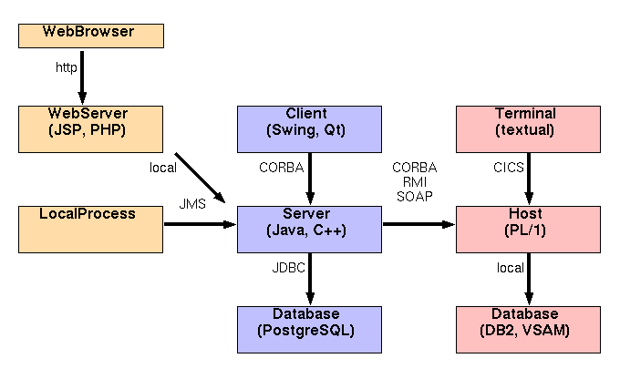
Fig. 5: Classical system design – Physical architecture, legacy

The logical architecture, on the other hand, is the inner structure of software. It is best divided into System (Application/Module) and Model (Business Domain):

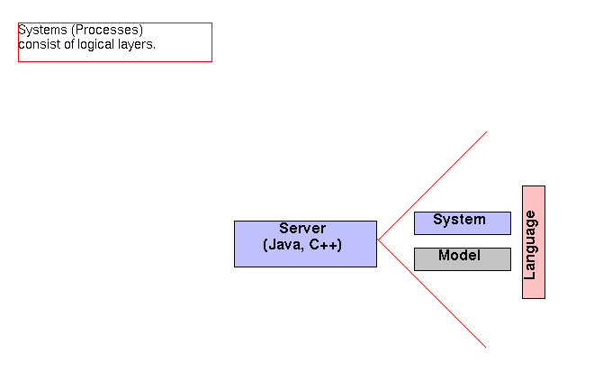
Fig. 6: Classical system design – Physical architecture: layers

In the past 10 years, since the application of Object-Oriented (OO) Techniques, systems are structured into so called Layers, consisting of pieces of software with logically similar functionality. Design Patterns play an important role in such architectures. A famous one is, for example, the Model-View-Controller pattern which devides a system into three parts:
- The Model, which contains structured domain data,
- The View that displays data,
- The Controller that manages the workflow.

Fig. 7: Classical system design – Logical architecture

New Systems using Ontologies extend this principle of layering a system and structure any system into Ontological Layers:
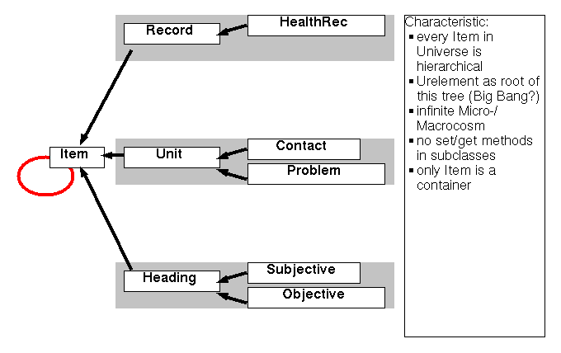
Fig. 8: CYBOP - Hirarchy

Latest achievements in software design are different Ontologies for the Model, e.g. Electronic Health Record data:

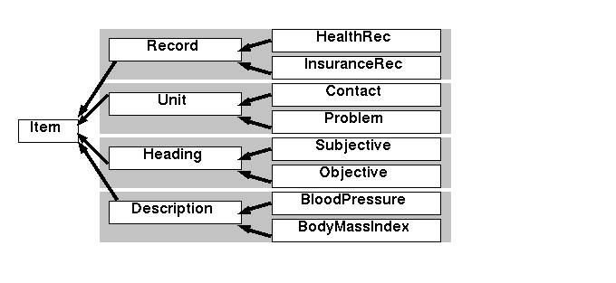
Fig. 9: CYBOP – Ontology model

and the System, e.g. Medical Documentation Module, Laboratory Module etc.:

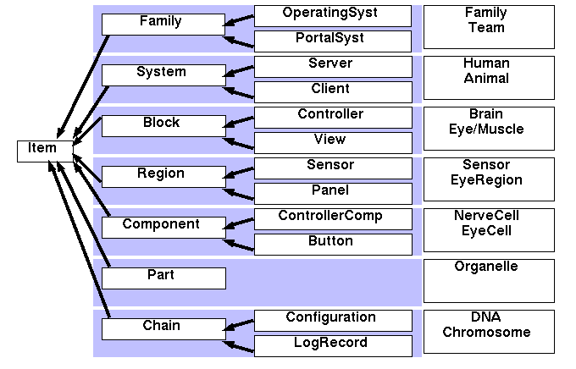
Fig. 10: CYBOP – Ontology system

Even computer languages can and should be seen as an addition of Ontological Levels:

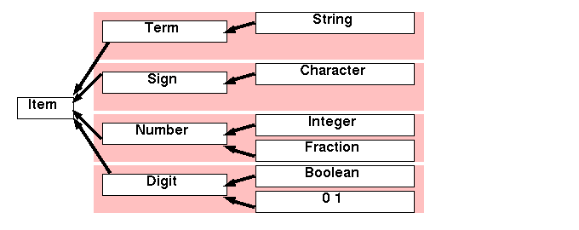
Fig. 11: CYBOP – Ontology language

Finally, System, Model and Language have to be brought together within a Class Framework providing common functionality:

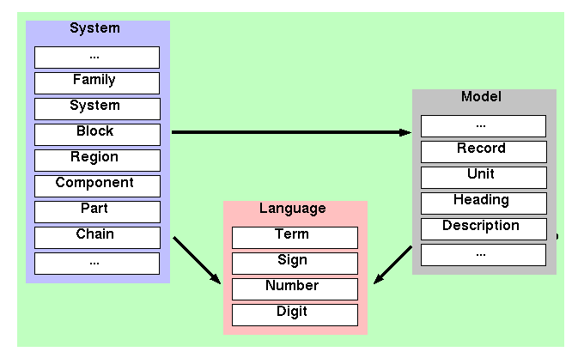
Fig. 12: CYBOP – Ontology: ResMedLib

When adhering to such a clear structure, it is easy to outsource single modules for each partner:

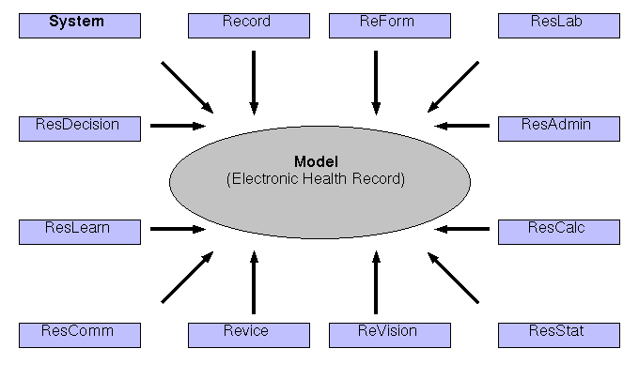
Fig. 13: Res Medicinae -analysisl

And in the end, they will all work together smoothly:

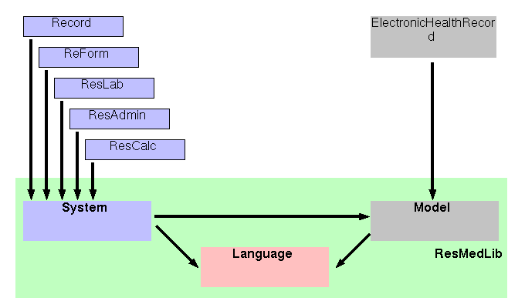
Fig. 14: Res Medicinae -design

At TU Ilmenau there will work 3 software developers in the project. Their tasks will be the following:
Software Engineer 1:
- designing overall framework
- ensure smooth integration of modules
- keep up with standardizing developments
- introduce clear Ontologies/Systematics/Class Structures
Software Engineer 2:
- frontend (GUI) capabilities (Swing, JSP, Web, Textual Console)
Software Engineer 3:
- backend (DB) and communication capabilities (JDBC, CORBA, RMI)
- creating a complete persistence and communication layer

Further developers are planned in by announcing student topics for diploma works etc. These students can help extending existing modules such as the one for Medical Documentation etc.

WP4: Maternity Hospital Electronic Medical Record
To design, develop install and maintain a Clinical Management Systems that brings together patient information across the continuum of care from the Mom’s pregnancy through the infant’s developmental care. This data becomes the foundation for improving the quality of care, reducing costs and ultimately saving lives at your hospital.

The system to be implemented should analyse the various stages of the Mom’s pregnancy, the various stages are:
- Antepartum
- Labour and Delivery
- Nurseries
- Developmental Follow Up

These can be further broken-down into the following Modules:
- The Perinatal Data Centre
- Track information from doctors and nurses during prenatal, admission, labour delivery and postpartum period
- Use data for research, outcome reviews and quality improvement.
- The Daily Baby Centre
- Real-time tracking of your neonates' day-to-day medical information
- Get stats with a mouse-click and automated discharge summaries
- The Antepartum Testing Centre
- Analyse your entire patient population based on outcomes and internentions.
- Record your patient's antepartum testing data.
- The Infant Development centre
- Get valuable insight into your clinic's practice patterns and outcomes
- Track the follow-up care of your high-risk infants
- Peranatal Office Connectivity
- Automate OB/GUM patient care charting
- Turn Patient Care Records into useful research and quality improvement tool.
The Perinatal Data Centre:
The Perinatal Data Centre is a state of the art data management and automated reporting software application for Labour and Delivery, Postpartum and Nursery departments. The Perinatal Data Center tracks information from both nurses and physicians during the prenatal, admission, labour, delivery, and postpartum periods, in addition to summary data for the regular and intensive care nurseries. All information resides in a secure, easy to use database, with analysis tools for tracking and managing outcomes for mothers and babies.

The Perinatal Data Centre provides tools that enable users to easily compile unit statistics, create provider report cards, perform focused audits, ICD-9/CPT and DRG code perinatal charts, produce delivery notes and discharge summaries, automate the production of the state birth certificate and much more.

The Perinatal Data Centre servers not only as transcription service and automated report generator, but as a giant filing system for maternal and newborn data that can be easily queried for the purposes of clinical pathway design and measurement, departmental quality assessment, statistical analysis for research and patient care review.
The Daily Baby Centre:
The Daily Baby is a revolutionary data management and automated reporting software application for the regular, intermediate and intensive care nursery settings. The Daily Baby allows the real time tracking of day-to-day detailed medical information on neonatal patients. A series of simple data entry screens guide the clinician through the documentation of a neonate’s stay in the nursery. Admission history and physical examinations, daily progress notes and discharge evaluations are all entered directly into the application utilizing timesaving data entry features, such as user- customized choice lists and exam templates.

Current handwritten medical record documentation results in the bulk of clinical information being buried in the chart making access difficult and time consuming. The Information that is entered into The Daily Baby is stored in a large relational database thereby providing clinicians with ready access to daily documentation for statistical analysis and preparation, fully automated report production, quality improvement and outcome reviews, clinical pathway design and measurement, physician practice profiling and patient billing activities.
The Antepartum Testing Centre:
The Antepartum Testing application tracks detailed information on patients during their in hospital antepartum testing visits. The Antepartum Testing application provides tools that enable users to generate easy to read visit summaries, visit logs and many other useful reports. When utilizing Antepartum Testing, reports and summaries can be automatically faxed to the patient’s prenatal care provider, CPT coded billing sheets can be produced and the scheduling component allows for tracking due dates and follow up visits.
When Antepartum Testing is used in conjunction with The Perinatal Data Center, the application links antepartum testing results and information with labour and delivery, and nursery patient data with high risk follow up visits. This integration provides a powerful framework for research and ongoing study.
The Infant Development centre:
The Infant Development Centre application is a unique data management and reporting tool for high-risk infant follow up clinics. The Infant Development Centre tracks data on infants that return for follow up clinic testing and evaluation. The system generates state mandated reports, visit testing results, and offers powerful scheduling and patient tracking features.
When used in conjunction with The Perinatal Data Centre and Daily Baby, the application links prenatal, labour and delivery, and nursery patient data with high risk follow up visits, thereby providing a powerful framework for longitudinal research and ongoing study. The application’s scheduling component allows for tracking by corrected or real ages at user definable intervals, also providing reminders for required visits.
Deliverables
- Automates patient tracking and scheduling
- Automates state and regulatory reporting
- Automated generation of provider letters, appointment reminders, patient lists and much more
- Easy to query relational database
- Linkage to labour and delivery patient data
- Linkage to regular and intensive care nursery patient data
Peranatal Office Connectivity:
The Systems' future product strategy is to link the data collected during the Mom's prenatal visits in the physician office to the delivering hospital. Future products will interface the Systems' hospital-based Application Suite directly to the various Clinical Office Systems. We believe there is significant value to the referring physician and the delivering hospital in completing this continuum of data from the beginning stages of the Mom's pregnancy to the Infant's developmental care. This connectivity will provide the capability of automating the charting of outpatient OB/GYN patient care, in addition to serving as the foundation for an integrated delivery system for maternal health.
Deliverables
- Improved outcomes and patient management
- Automated reporting
- Integration between inpatient and outpatient record
- Produces standardized legible documentation
- Centralized access to patient chart
Being the Core (Main) Module of the whole Healthcare Information System, this module must provide the possibility to open submodules and as such serving as a Portal Module:
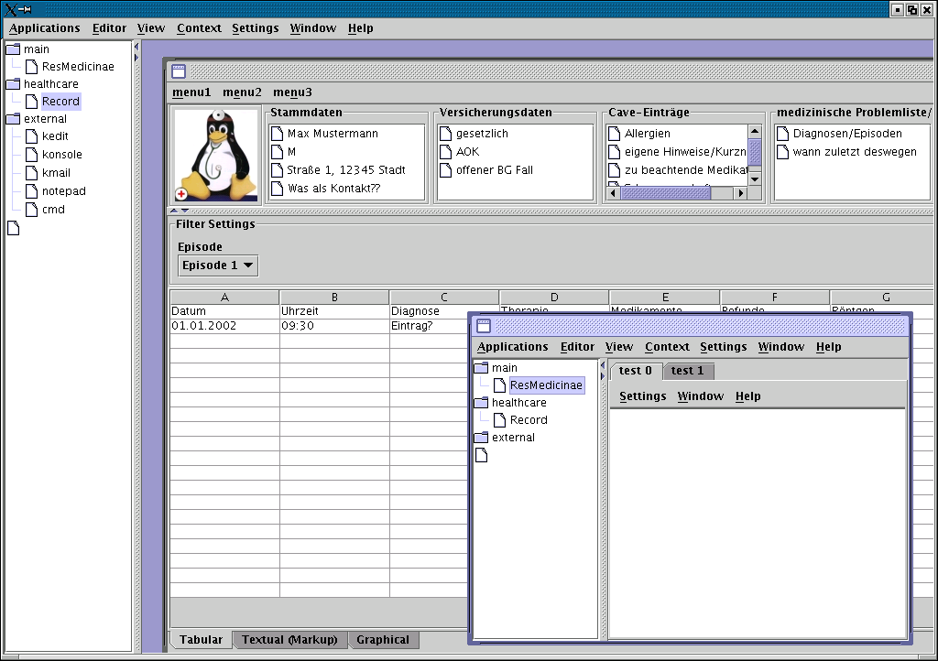 Fig. 15

Also, it should provide the possibility for doctors to do a Topological Documentation, i.e. get graphical support in documenting Illness and Diagnosis:
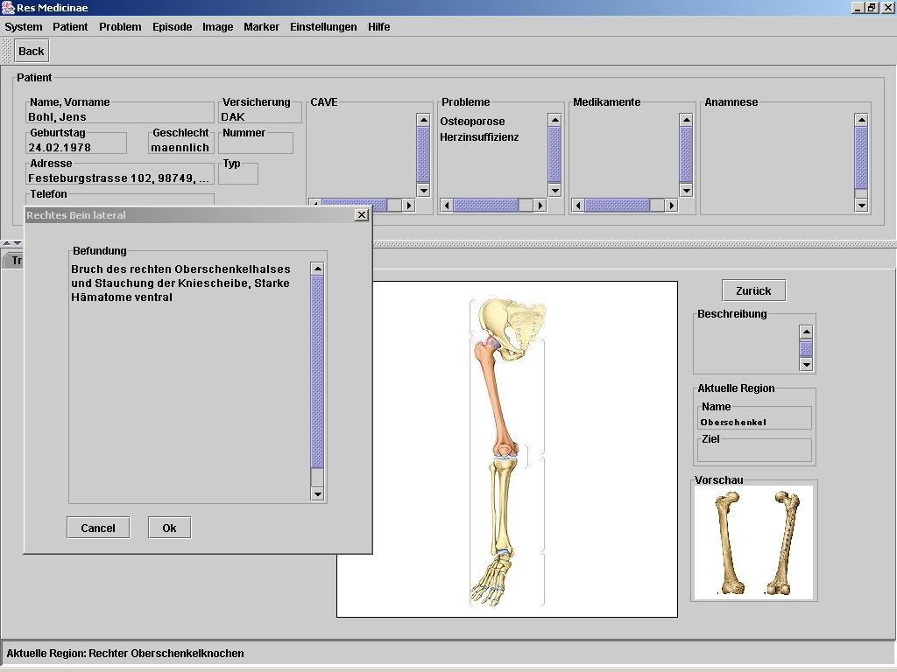 Fig. 16

Finally, the Electronic Health Record Core Module must provide functionality for Report Generation and Form Printing which are still needed nowadays in clinics and hospitals:
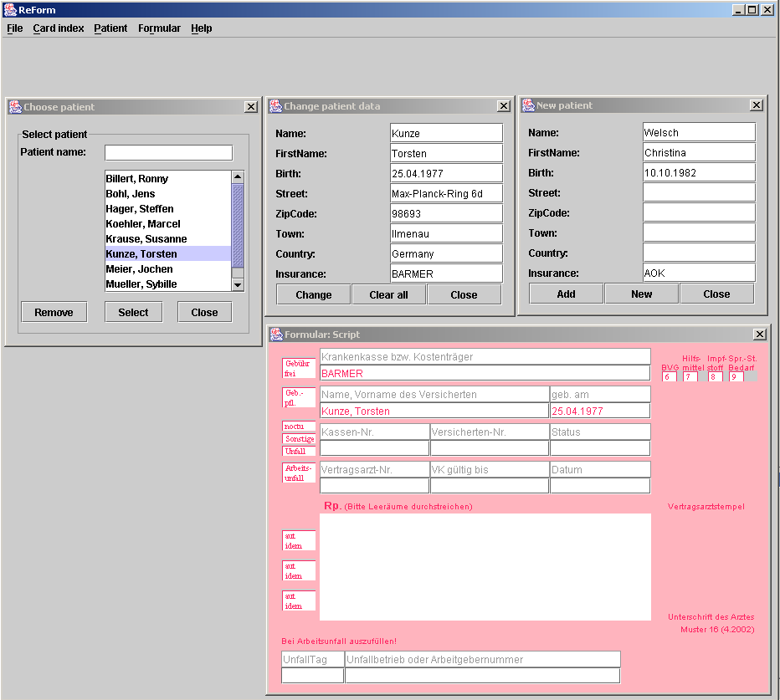
Fig. 17: Example for Electronic Health Record Core Module

WP5: Drug Information and Interaction Database/Connecting Clinics
Motivation (Drug Database)
Hospitals are patient centered organizations; therefore, patients are their main focal point. Indeed, most of the hospital processes are geared toward patients: admission, inpatient and outpatient events, invoicing, communication with health insurance providers, etc. Moreover, for the effective support of most medical doctor’s practices in a hospital there is a strong need for an appropriate HMR.
However, this is not the only critical module within an integrated health support environment. Another component that plays a crucial role in hospital systems is the drug database and interaction (DDI) module, which should incorporate both drug information and drug interaction capabilities. Drug Information should cover important facts and data. Drug interaction occurs when the effect of a particular drug is altered when it is taken with another drug, or with food. Thus, the drug interaction database should explain the mechanism of each drug interaction, the level of significance of the interaction (major, moderate or minor), and in certain cases, should provide the recommended course of actions to manage the interaction. Having a well designed database, with drug knowledge being expertly stored, retrieved, managed and evaluated, the DDI module can provide up-to-date, clinically-relevant information on all drugs, as well as off-label uses and dosages, references, trade names and manufacturers. However, the goal is not to have just one more disintegrated system, like the ones that can be found in the INTERNET or delivered in CDs. While those are usually consulted off-line as Vademecums, the target of this sub-project is to develop integrated systems like the ones that will be described below.

Consequently, one of the most important features of a DDI module would involve querying the database in patient-specific ways (For instance, by interacting with the HMR while the physician is making a prescription), so that the following aspects could be considered:
- detailed profile of the patient’s therapeutic regimen to be able to identifying potential interactions
- detecting adverse reactions, contraindications, allergies
- drug/medical condition mismatches

However, the DDI module is not only important due to its natural interaction with patient care modules, but also due to its strong connection with other business processes, like the ones that manage the supply chain associated to the health care system. As in Production enterprises, where there are close links between the Products’ Data Base and the inventory management system, in health care organizations there is a strong link between the Drug Database and the Pharmacy System, where drug’s inventory is actually held. Supporting this interaction would allow maintaining cost effective and integrated inventory systems, communication with providers, to develop more efficient procurement processes, etc. Thus, by letting the three modules (Patient HMR, Drug Database and Interaction and Pharmacy Management System) to cooperate among themselves when a clinician is making a prescription, not only any possible interaction, right dosage and contraindication may be verified and tested beforehand, but also the availability, cost and expiration date of the drugs in the Pharmacy system under their different trade names. (An example of a trend towards the goal of a patient-related ordering of drugs and medical supplies).
Objectives (Drug Database)
This subproject aims at developing the architecture for a DDI module, within the framework of an integrated environment for the secure exchange of healthcare information. The DDI module should be able to:
- provide reliable, high quality drug information
- search its drug database by drug type, brand/generic name or medical/health condition
- supply helpful, reliable information on how different drugs interact with, or react to, each other
- update the data base when products are added and/or removed

Furthermore, it should consistently interact with the both, the HMR and the Pharmacy inventory facility, the latter having information about the stock level and expiration date of the different brands of each drug that is held in stock. Finally, by the proper handling of information it would be desirable to correlate the diagnosis and prescription functions of the system.

For demonstration purposes, the above described modules will be developed and tested at the Children Hospital, Dr. Orlando Alassia, located in Santa Fe, Argentina. The current information infrastructure of this hospital is minimum, not being active any support system able to handle drug information and interaction, to manage the pharmacy and procurement systems, etc.
Motivation (Connecting Clinics)
The primary pediatric care is considered as one of the pillars for the public health system in Argentina. An important component of this system is composed by very small clinics (Distributed Small Clinic, DSC), called dispensaries that are located in poor suburbs and nearby rural areas. The overall goal of this subproject is the interconnection of a reference children hospital with many DSCs.

The pediatric medical attention in Santa Fe (Argentina), is basically organized around a pediatric central hospital (PCH), named "Hospital de Niños Dr. O. Alassia", which is the reference center for small clinics that are distributed in a big area in the northern and center part of the state of Santa Fe. These small clinics are in charge of primary health care, mainly in areas populated by poor citizens, and are the natural detection places of epidemiological symptoms.
As a reference center it is required to the PCH to provide information to DSCs in order to standardize the adopted diagnostic and therapeutic criteria. The supplied knowledge should also include information about the current state of the area health situation. Furthermore, the PCH is supposed to provide continuing educational support to the DSCs. However, almost none of these functions are accomplished now because the only existing communication medium among the nodes of this health system is the telephone.
In the current health care system, children are usually controlled and treated in their neighborhood DCSs, where paper medical records are handled. In cases of serious pathologies, or when special studies are needed, patients are hospitalized in the PCH, where a new medical record is opened (which is not in a complete electronic form). Once released from hospital, patients usually continue their treatments at the DSC. The proper operation of this system would require the DSCs and the PCH to have to access to a common patient record. However, this does not occur nowadays. Indeed, it would be desirable for the DCS to be able to get and update information retrieved from the PCH patients record system, and conversely, it would desirable for the PCH to trace and track patients’ evolution at the DSCs. Another aspect to be considered is that these DSCs are the natural and first monitors of certain abnormal tendencies in the health status of the children population. It is necessary that this information could be obtained by the reference center in order to analyze it, assess health needs, identify target groups, enable special programs and monitor the progress of taken actions and health promotion initiatives.
Finally, DSCs and PCH should be able to interact in order to communicate to each other, both the corresponding requirements and availability of the different resources (e.g., at a DSC a given physician may want to check the available slots for performing a certain study at the PCH).
Objectives (Connecting Clinics)
This work package’s task will be to investigate on the hard- and software requirements, for easy interconnection among several Distributed Small Clinics and a Central Pediatric Hospital. This subproject aims at developing an architecture of a web based system, able to connect and support suburbs and nearby rural areas (distributed remote or small peripheral Clinics in Argentina), DCSs, with a children reference center, PCH, in order to be able to:
- access and update a unique EHR
- share consistent therapeutic and diagnostic criteria, aiming at delivering high quality health care services
- access data bases storing health cases and incidents,
- access the different PCH resources and their timetables.
- monitor epidemic information from rural and peripheral clinics

In order to design the system architecture the subproject will go through a detailed analysis of the current scenario in order to:
- derive more specific functionalities of the system, and the required hardware, software and technological standards
- identify actors (users), their roles, and the particular tasks they have to perform
- recognize the new skills users must acquire to accomplish these tasks and
- identify the kind of training that users would need

Design and performance of an adequate training program are critical issues to ensure the success of any telemedical system. In the situation tackled in this subproject, it is necessary not only to introduce a technological change; there is also a need for a culture change in order to start the operation of new processes in children health care.
The goal of this subproject is to have fully functional web based telemedical services. The central node at Children Hospital Dr. Orlando Alassia of Santa Fe, will support the health care teams of the DSCs, providing also tele-assistance and tele-education services. Tele-assistance services include synchronic and asynchronic tele-consultation, and access to health personal records. Tele-education services are going to include, initially, on-line case discussions and asynchronic study of cases and consultation of PCH databases.

WP6: Patient and Resources Scheduling - Management of Patient Support
The overall health process of some patient, ie. the practice of medicine in some hospital (Health Public Service) must be available (open) to the ones in charge to give the necessary support at large, not only in terms of data (history, profile, clinical facets, problems, test results) register, but also in what concerns the monitoring of medical acts in due time. This means the need for some intelligent agent (monitor) behind the scenes, in charge to control the responsibility of that process management, and also of other agents fullfilling specific roles around the care of that patient. The agency is a public service focused on the patient interest and desires, always prepared to help him in all circunstances.

Such a patient (decision) support system can be available (but not completely open) to the one most interested (the patient), by several means (phone, fax , internet, email) in order to receive further contacts, such as requests, inquiries, or statements about new symptoms, and be able to offer an easy communication by delivering advice, technical help, alerts (remember an appointment, inform about the impossibility of some service because of a strike), and ongoing care driving. This capability can be supported by an automatic, and on line, access to the patient doctor or to some other more appropriate clinician.
Tasks:
- Definition of an ontology of the doctor language (vocabulary) for a particular domain.
- Design of the global architecture of such patient support system as a multiagent society (agency). Defintion of the agent´s roles.
- Classification of technical recommendations (contact doctor X, treatment of a disease, make a test, observe temperature, drink more water) in function of the patient history.
- Study of the most advisable management of appointments and medical acts in due time (precise time table): indication of the specific place and person in charge (name of best contact).
- Recommendation medical ways taking in account their uncertainty and fuzziness.
- Sketch of a patient aid portal to be available to those needing medical support in a hospital.
- Study of the links of this new facility to the other existing hospital systems.
Means:
- Computer equipment
- Human resources (grant for a informatics graduate)

WP7: Medical Terminology Service
Contribution:
Providing contact to the HL7 community and the XML healthcare development group which is engaged in the integration of national standards like xDT and international standards like HL7 or DICOM.
Use cases:
- Translation of medical terms. Since several years we take part in the Unified Medical Language Project (UMLS) of the National Library of Medicine (NLM, USA). With more than 750,00 concepts and more than 2 million concept names the actual version of the UMLS Metathesaurus is the largest source of this type. The UMLS Metathesaurus includes several translations (including German, Spanish, and Portuguese) of the Medical Subject Headings (MeSH). The MeSH catalogue can be used to translate e.g. a German diagnosis into a concept and the appropriate English term. One task will be to define and implement an interface between the medical record system and the UMLS Metathesaurus to offer computer based translation of medical terms for the end user and to support decision support based on concepts instead on variable medical terms.
- Secure transfer of data between partners in an integrated medical environment. To demonstrate the secure exchange of healthcare information provided by the system a connection between a major laboratory services provider in Cologne and general practitioners will be established. Based on the German LDT standard for communication between a care provider and a pathologist an electronic order will be translated into the system’s standard, entered into the system and transferred by the system to the pathologist’s system. After the analysis is performed the result will be transferred back to the sender.

WP8: Decision Support, Data Mining
Both, UFRGS and UnB team will be concerned with the Decision Support subsystem. The UFRGS group will focus medical diagnosis based on Bayesian networks and will concentrate on the implementation of the Decision Support Module. UFRGS has already developed a tool for that end which is today part of an environment named SEAMED. SEAMED presents a graphical interface designed to ease the construction of decision-making support applications in any medical field. In order to analyse a specific case, the application user should enter the available evidence. The application propagates this evidence through.
The UnB team will focus on the use of machine learning (data mining) techniques to build Bayesian networks, decision trees and naive Bayes. The UnB team will also work with the associative rules approach. The tools that will be development will be put available through the UnBBayes framework, a web service tool based on both XML and SOAP protocols. The UnBBayes framework is being built with the Java programming language and class library. It will have multi-language support.
Decision support tool description
This environment was designed to support training of diagnostic reasoning and modelling of domains with complex and uncertain knowledge. It was primarily intended for learning, but in the context of the Aesculapius project it will be used to support medical diagnostic. This diagnostic tool deals with uncertainty under the Bayesian network approach. We chose Bayesian network approach to deal with uncertain knowledge because it is mathematically principled. Bayesian networks have been widely used all over the world to model uncertain domains [2]. Another important reason for choosing the Bayesian network approach is its twofold feature that enables qualitatively and quantitatively domain modelling.
SEAMED environment is composed of two modules. The Domain module represents the expert knowledge domain (Figure 18) and the Bayesian network editor (Figure 19) with the expert can create new knowledge for the diagnostic tool. This model will be used in the aesculapius project to build the diagnostic. Where we had a learner before, now we have a physician.
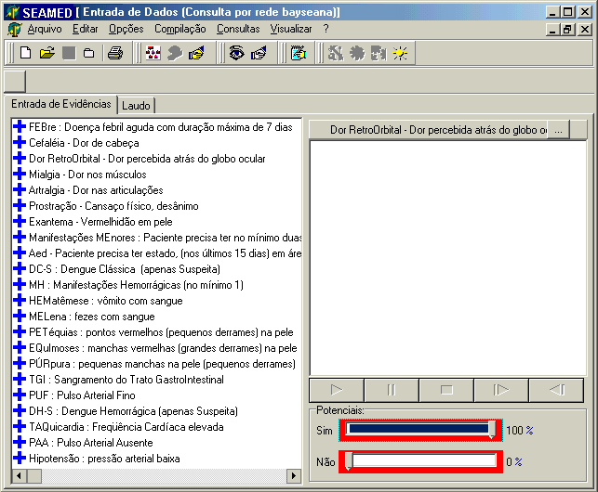
Figure 18 - Domain module
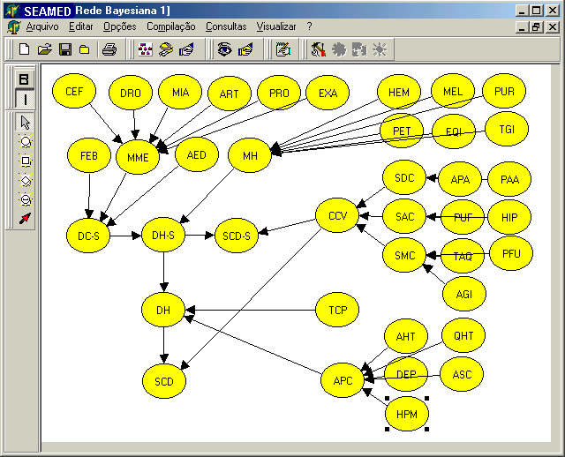
Figure 19 - Bayesian network editor

We follow the hypothesis that a physician engaged in medical diagnosis implicitly performs probabilistic reasoning. The physician’s practice corresponds to take full advantage of the probabilistic relationship between the variables present in a Bayesian network that models the medical domain of interest. Reviews of published case studies in the domain of environmental Medicine support this hypothesis [2,12,17,32]. More generally, there is empirical evidence that the probabilistic reasoning, when supported by Bayesian networks, corresponds closely to the human reasoning pattern [33].
The process of formulating a definite medical diagnosis can be seen as composed of the following steps: medical interview, CDH (Current Disease History), formulation of a differential diagnosis, formulation of a preliminary diagnosis, and definite diagnostic formulation. If suitable, after the formulation of a preliminary diagnosis and before the definite diagnostic formulation, the physician can review the technical literature and request complementary lab tests. In medical interviews, the physician interviews the patient to know the history of his/her last diseases. To obtain the CDH, the physician questions the patient about what his/her main complaint is. The physician visually examines the patient in order to determine his/her condition, searching for signs on the body, and notes down the symptoms the patient mentioned. Then, the physician examines the patient physically, oriented by signs and symptoms already detected. With all these information, the physician makes the differential diagnosis, that is, selects a set of pathologies (diseases) compatible with the data collected, and tries to get new results that can exclude some hypothetical pathology. Through reducing the set of hypothetical pathologies, it is possible to establish the preliminary diagnosis, that is, to determine the most probable pathology. If there is need of confirming the preliminary diagnosis, the physician requests supplementary investigations. While the physician waits for the lab results, he/she can review the technical literature about the pathology he/she suspects the patient is suffering from. The lab tests analysis can confirm the preliminary diagnosis, making it definitive, or supply new information for a new preliminary diagnostic formulation.
The use of probabilistic systems to support this medical procedure can make easier the differential, preliminary, and definitive diagnostic stages. It can reduce the need for technical literature review and complementary lab tests but does not reduce the definitive diagnostic quality. Therefore, it can improve the medical diagnostic quality, reducing both the time needed to make a diagnosis formulation and costs. This reduction of costs is associated to the expectation of a change in the physician’s behaviour. We expect that, if the physician has a probabilistic model that helps him/her with the diagnose process then the lab tests requests will decrease. Lab tests will be requested only in cases where it is not possible to get the definitive diagnosis based on interviews and analysis of the hypothetical disease the physician is considering possible, having in mind the patient's main complaint.

The characteristic uses of the UnBBayes web services are the:
- building of prototypes of medical domain models based on Bayesian networks, naive Bayes or decision trees through the applying of machine learning techniques into large sets of real medical records
- discovery of medical knowledge based on the applying of associative rules algorithms to large sets of real medical records
The Bayesian networks models built can be used by the UFRGS tools, mainly the SEAMED for medical diagnosis propose.
Work-plan
We intend to take the SEAMED, and integrate it with the components the other partners of the Aesculapius project will supply. For that end it will be necessary to know with details all components that each partner will bring to the project. The decision support module will need to be integrated with the system as a whole. This phase will take about 8 months to be fully developed and implemented.
After that, we intend to begin the testing phase in order to see if the diagnostic system that worked without problems in our environment is working without bugs within the Aesculapius portal. We intend to take 7 months to accomplish this.
After the decision support tool is working without problems we will begin tests with the tool's distance users. For that end we intend to follow logs of about 30 remote users and report all actions, their consequences and implications. Questionnaires will be sent to users in order to make, besides a quantitative analysis, a qualitative analysis of the tool, such as satisfaction, usefulness, easy-of-use.

Activities | Month 1 – 12 (2003) | Month 13 – 24 (2003) | Month 25 – 36 (2003)
To integrate the decision support module with the system as a whole | ********
The testing phase (to see if the environment SEAMED is working without bugs within the Aesculapius portal) | **** | ***
To follow logs of about 30 remote users and report all actions, their consequences and implications |  | ********* | ************

WP9: Traffic Accident Care
Objective
It has been shown at national level that audit of trauma care improves outcome. Throughout Europe and Latin America national trauma databases have been set up. Each national database collects slightly different data. This prevents meaningful cross-boarder comparison and preventing dissemination of best practice. We propose to establish a European – Latin American wide database in order that these deficits can be corrected and that the future database could become a useful research tool for the future development of trauma prevention and care.
Some of the data entities that maybe included in the database are demographic data of persons with major trauma, incident data – type of injury, road conditions etc., emergency care delivered at the accident scene, at the hospital(s), subsequent care, outcomes, rehabilitation - legal, social, psychological support services provided, cost figures for casualties and delivered care. We see certain data from the Abbreviated Injury Scale (AIS), and the TRISS severity scoring system as being core data, which should be collected by all members.

The objective is to strengthen the performance of healthcare providers in Trauma Care, prevention and rehabilitation, in innovative new roles by:
- consolidating, packaging and translating relevant health care, clinical and technical standards and best practice guidance in electronic content form (e-content);
- providing support for the creation of a common European– Latin American research base (web-based applications – knowledge management)
- facilitating the design of European– Latin American injury control and epidemiology programs
- providing policy support and stimulating strategic development between healthcare authorities and healthcare providers;
- disseminating information on innovation in Trauma Care Units management and encouraging the transfer of knowledge about good practice in policy making, service development and delivery
Need
Trauma is the commonest cause of death in the 1-40 year olds and generates considerable morbidity in a relatively young population. Thus any improvements in trauma care are likely to be cost effective. The establishment of a European– Latin American database would prevent duplications at national level, again generating a cost benefit and fostering a spirit of synergy throughout the countries. Such a database would also identify different local problems and injury patterns as they vary from country to country allowing locally targeted interventions.
Proposal
The proposed work will include:
- Definition of a business model – processes for data collection, analysis and use by different partners from different countries
- Interoperability between national databases
- Advanced methods and technologies for extracting knowledge from injury databases - injury patterns for different countries
- Decision support for locally targeted interventions
- Technologies to be used: DB, WEB, GIS, Data warehousing, Data mining

Partners:
- GRNET (open source initiative)
- EFTHITA (National Trauma Registry)
- Health Region of Ionian Islands (pilot site – 5 hospitals)

WP10: Laboratory Data Retrieval and Management in Primary Care
Introduction
The primary care, considered as one of the pillars of the Unified Health System (Sistema Único de Saúde - SUS) in Brazil, it has been objective of a series of attempts to offer some information systems, to supply different needs, in different moments. Besides the current problems of the integration lack among those solutions and of these with the systems of information in national level, little or no attention was given to the representation of the clinical information.
This project is centered in the articulation of those two subjects: one regarding the work process in the primary care, that intends to incorporate the Program of Health of the Family (Programa de Saúde da Família - PSF) to a Health Center that offers primary healthcare. The other one regarding the development of a system of information directed so much for the managerial support as for clinical decision, that incorporates solution of representation of clinical data and guarantee interoperability, factor that still needs to be solved by the systems information in Health, although it is issue of debates and publications there are already some years.
The following premises are being incorporated:
- it is accepted more and more in the whole world, that the systems of information in health centered in the person, and that they favor the idea of the patient's electronic record strongly, in the solutions gone back to the health area.
- the National Health Card System (SCNS), that it signals the possibility of the direction of solutions of some problems, be the use of the number of the card SUS as proposal of integration solution among the systems of information in health, be a series of relative standardization to the patient's attendance and the electronic transmission of data;
- PSF comes being considered as the main strategy of overcoming the access problems to the services of health in Brazil;
- portability and interoperability warranty
Objective
To develop an information system for units of primary care, based on the patient's electronic record, in order to support to the decision of the direction of the unit and of the professionals of the team of health, including support to the clinical decision. It is being foreseen the disposability of the interfaces for the functions of the systems of information in health of SUS, including National Health Card System and to offer support for relationship with the net of services of health.
Methodology
The intersection formed by three thematic fields, as know: Technology of Information, Administration of Services of Health and Support to the Clinical Decision, they constitute the context of the subjects that they will be approached, through the use and theoretical and methodological development of the instrumental:
- “workflow " use - in the structuring of the work process, including the incorporation of PSF to the Center of Health;
- of the software architecture - UML - in the modeling of the work process;
- of the planning and administration in health - for definition of indicators;
- of the statistics - for the intensive employment of the resource of the analysis of data and for the handling of great volumes of information;
- of the Clinic - for creation and maintenance of protocols.

This work is being developed at Health Center School Germano Sinval Faria (CSEGSF), which is a department of ENSP, and which possesses teams of PSF and offers medical specialties and graduation education in public health.

WP11: Legal Constraints and Requirements
To establish the Legal Constraints and Requirements that Impact upon the Development and Implementation of Electronic Health/Patient Records Terms of Reference for Consultants
Background
Electronic records must enable Health Service organisations to comply with all relevant legal, ethical and policy requirements including, most notably, standards stemming from legal and ethical duties of confidence, from the Data Protection Act 1998 and from the Government’s commitment to informed patient consent.

In terms of legal/ethical requirements, a range of different types or categories of people have an interest in a patient’s electronic record:
The patient who is the subject of the record;
The professional with primary responsibility for the patient’s care, e.g. the Doctors in primary care or the lead consultant in secondary care;
Other professionals who contribute to the record and/or to the patient’s care;
Others who provide detail to clinicians that is included in the record (the patient’s family members etc);
Those interested in the content of the record for secondary purposes (research, epidemiology, surveillance etc).
Each of these is, or may be, treated differently in law. Electronic records need to have the capacity to reflect and respect these differences.
Project Objectives
The main objectives of the project will be to:
Identify all requirements provided by law, ethics and policy that impact on how electronic records should be structured and managed.
Identify options for satisfying the identified requirements; appraise cost/design implications for implementing each option over a range of timescales (1,3,or 5 years).
Project scope
The scope of the study includes:
Review of policies, guidance and legislation to identify full range of existing standards/requirements that have implications for electronic health/patient records;
Consultation with policy makers and those who set standards (e.g. the General Medical Council and the Information Commissioner), and also with IM&T (Information Management & Technology) professionals who will be responsible for implementing the new systems;
Working with organisations that will develop, supply and maintain systems, and provide training to users.
Deliverable
A report that sets out the legal, ethical and policy requirements which govern the structure, functionality and management of electronic records;
A detailed appraisal of options that would ensure that electronic records have the capacity to meet these requirements.

WP12: Exploitation and Dissemination of Results
Objectives and Approach
The purpose of this workpackage is to provide the maximum visibility and public awareness of the project objectives, technologies and achievements. The following activities will be carried out for this purpose:
- Establishment of a project Users Forum, where healthcare provider, NGOs, public institutions and research organizations will be invited to participate
- Continuing user participation in the development of concepts and consensus development for and consensus development of AESCULAPIUS platform
- Dissemination activities for the results of AESCULAPIUS – publication in international magazines and conferences
- Development of a website and production of pamphlets-leaflets-posters to display and disseminate project concept and achievements
- Preparation of exploitation plans, contact with sponsors and industrial partners

This has been placed in a workpackage on its own because of the emphasis, which the consortium wishes to put on concentration, user participation and dissemination. This workpackage will be responsible for the production of information materials and ensuring the project is represented at important conferences and exhibitions.
Activities
- Development of concentration plans liaison with other similar projects
- Establishment of the Users Forum and co-ordination of user group meetings and activities in relation to innovation and consensus development.
- Dissemination activities including participation at conferences and exhibitions.
Deliverables
- Users Forum set up
- Dissemination strategy and results
- Exploitation plan

Methodology
It is proposed to use the PRINCE project management methodology, which has been used within the health and social services in the UK as a standard for project management since 1989.

On commencement of the project, a Project Board will be appointed and will be made up of a senior representative of each partner and will be responsible for overall guidance and direction to the project. All members of the Project Board and others playing key management roles within the consortium will be offered training in PRINCE.

The representative of the prime contractor will act the Executive and will chair the Project Board. Two Senior Users who play a lead role are been appointed to provide strategic advice to the Project Board on user issues. A Senior Technical adviser is been appointed and will provide strong support to the Project Board and the Project Manager in relation to the co-ordination of the software development, integration and implementation. The prime contractor will appoint a Project Manager.

The Project Assurance Team consisting of Business and Technical Assurance Co-ordinators and a User Resource Person will support the Project Manager. Individuals selected for these positions because of their skills in each of these areas respectively. The Project Assurance Team will provide assistance to the Project Manager in planning, monitoring and controlling the project and in providing expertise in the relevant areas. The Project Manager will be responsible for preparing a project implementation document for approval by the Project Board and which should include the objectives, organisation, plans and milestones for the whole project.

A Quality Review Team will also be appointed to ensure all deliverables are of acceptable standard before delivery to the Commission. A representative with experience in research and development in European projects will act as the leader of the team. He will ensure that two representatives of the team are appointed to quality assure each deliverable. The project manager will be responsible for sending the deliverable to the European Commission.

The project is divided into a series of workpackages and a Workpackage Leader and Project Team has been assigned to take responsibility for each workpackage. A separate project initiation document will be prepared for each workpackage. The workpackage leaders have been selected based on their expertise in activities within each of the workpackages. They will be responsible to the Project Manager for the execution of the workpackage.

Fig. 20: Project structure AESCULAPIUS

While PRINCE methodology requires a very structured approach to the execution of projects and comprehensive documentation, it is recognised that collaborative projects involving partners across several European and LatinAmerican countries are complex and difficult to manage. An advantage of PRINCE is that it identifies the risks to the successful completion of the project and problems are identified at an early stage. It is proposed to adapt PRINCE to the needs of the project.
Technical Co-ordination and Advice
A particularly important part of the management of this project is seen as the co-ordination of the development and integration work of the software companies. The technical adviser will play an important co-ordinating role and will work with the technical partners within the workpackage teams. The technical assurance co-ordinator will liaise closely with the technical adviser.
Decision Process
The Project Board will be responsible for the overall direction of the project and all partners will be represented on the Project Board. In the event where there is disagreement within the board, all partners will have one vote and the majority vote will carry the decision. Where one partner is unable to undertake the work that they have agreed to do or consistently fail to deliver, the Management Board may agree on transferring the funding for that work to another partner, provided that at least two-thirds of the partners vote in favour (excluding the partner in question).

It is proposed that an executive team should be identified within the project Board. The executive team will make recommendations to the Project Management Board and will have the power to make decisions between Project Management Board meetings if necessary, reporting back to the Management Board. This team will consist of the executive chairman, the two senior users, the technical advisor, the project manager and the chairman of the quality review team.

The project manager will be responsible for decision-making on operational issues with the support of the technical advisor, business, user and technical assurance co-ordinators. Workpackage leaders will be responsible for the execution of their own workpackages within the agreed plan for each workpackage.
User Involvement
The user sites have the potential to provide a very strong multi-disciplinary professional lead and quality assurance to the project. It is therefore proposed that user involvement will mainly be provided from within the project. The consortium will seek opportunities to present the results of the project to other users. It is proposed to create a network of centres of excellence within the project to aid the process of dissemination and consensus development.

Assumptions and Risks

Key Risks | Main approach to risk management
Business Risks
Future changes to National Targets and priorities | - Obtaining clear commitment from @LIS/EU to the Programme definition  - Ensure regular meetings with Ministers to ensure objectives and priorities are in line with requirements  - Ensure membership of lead official on the Department o Health Board
Lack of co-operation and buy-in by Health Service stakeholders to investment objectives | - Full involvement of interested parties  - Clear leadership from Department of Health
Inadequate Scoping of Project | - Assessment of relevant documentation (Health Service Plan, Department of Health targets, Information for Health, and updated @LISs etc);  - Preparation of business cases  - Consultation with the programme board  - Manage in deliverable chunks
Infrastructure not future proof | - Align with international standards
Services are not affordable | - Need to scope the programme accordingly
Implementation Risks
Lack of commitment to project by key user groups | - Health Service Modernisation Agency to provide implementation leadership and support  - Strategic Health Authorities to provide clear leadership  - Collect evidence from local delivery mechanisms to ensure consistency with national strategy  - Ensure involvement of interested parties in national programmes
Individual organizations in the Consortium act unilaterally | - Project coordinator to provide clear leadership  - Set targets through Performance  - Management
Shortage of required local skills etc. | - Minimise at national level by transferring risk to the private sector partners  - Strategic Partner to be responsible for identifying staff of sufficient calibre  - Allocation and ring fencing of required staff and skills
Difficulties of migrating from current arrangements | - Adopt a clear communications strategy to facilitate local planning  - Proper transition planning and trining
Slow or non-realisation of benefit | - Benefit Realisation Plan and Study to be incorporated within each detailed programme plan  - Performance Management of targets
Service Risks (Design, Build, Finance and Operate)
Technical incompatibilities | - Liaise with appropriate technical bodies to ensure compatibility  - Align with international standards
Supplier side capacity and capability | - Establish resource and commitment targets from suppliers and monitor as part of the contract process
Poor service levels | - Setting of key performance and availability targets  - Set up effective management board with user involvement
Partner(s) does not deliver | - Put appropriate project management and reporting arrangements in place
Cost escalation | - Budgetary Control – fixed investment ceiling  - Clearly defined review points  - Regular monitoring and exception reporting
Costs cannot be predicted | - Develop cost model as part of contract negotiation
Lack of skills to develop supporting standards and products | - Include training requirements in scope
Lack of training support | - Include training requirements in scope

Duration and project time table
WP | Work Package Name | Year 1 |  |  |  |  |  | Year 2 |  |  |  |  |  | Year 3
WP1 | Management | 0 |  |  |  |  |  |  |  |  |  |  |  |  |  |  |  |  | 36
 | 2 |  | 2 |  | 2 |  | 2 |  | 2 |  | 2 |  | 2 |  | 2 |  | 2
WP2 | General Framework / Best Practice | 0 | 4  1
WP3 | Legal Constraints and Requirements | 0
 |  |  |  | 3
WP4 | Electronic Health Record
WP5 | Drug Information and Interaction Database
WP6 | Medical Terminology Service
WP7 | Decision Support
WP8 | Traffic Accident Care
WP9 | Laboratory Data Retrieval and Management
WP10 | Implementation, Testing, & Validation
 |  |  |  |  |  |  |  |  |  |  |  |  | 5 | 4 |  |  |  | 6

The milestones and deliverables of the projects (Key Milestones)
- User Requirements: Collection and Analysis finished. User Requirement Document
- Legal Constraint Requirement
- Implementation completed.
- Final Test and Validation Report
- Interim Evaluation Report
- Final Evaluation Report

Project Time Framework
Fig. 21: Project Time Framework AESCULAPIUS

Expected results

Description of the functions of the demonstrator
The demonstrator will provide the basic functionality necessary to build up an integrated healthcare environment including GP’s, the local and the central hospital, the emergency services, pathology laboratories and pharmacies. Therefore it will include:
- A database to store the EHR which includes the following key components:
- Patient administrative data
- Potentially life-saving information on existing conditions, medications and allergies
- Actual and former conditions, procedures, medications, therapies
- Patient contact data (e.g. visits)
- Results data (e.g. pathology tests, x-rays (including images))
- Ongoing and former orders
- Standardized interfaces for the seamless integration of information from other systems (e.g. RIS)
- Care provider administrative data
- Terminology (vocabularies, enabling proper automatic processing such as decision support to be performed)
- Reference data (e.g. drug data). This data is essential for prescribing in GP or hospital situations, and decision support regarding suitability of medications or therapies.
- An interface for the patient to retrieve it’s own data and to add certain self measured data.

- Security and access control services. Security services enable demographic entities to be authenticated and authorised at all levels in the healthcare environment. The access control services defines the mapping between user stereotypes and available functions in the environment. In addition all services (e.g. key generation, firewalls, gateways) necessary to build up a virtual private network between project partners will be provided.

- An interface model for the seamless integration of patient related data from other sources which is a prerequisite to integrate additional care providers on demand.

The demonstrator will provide an environment in which the true interoperability among several parties and systems used in patient care can be tested and demonstrated. Since this is in parts more than a minimally functional EHR environment the project has to focus on a smaller medical entity. In modern health systems, each episode of care will be delivered by multiple professionals. For example, a patient is seen by a GP, is referred to a specialist who performs certain tests, interprets the test results, makes a diagnosis, formulates a care plan, and updates the GP on the patient’s situation. Depending on the diagnosis the patient has to visit a hospital and/or additional healthcare specialists. A typical vivid scenario, which includes all these processes, is the pregnancy. The demonstrator will support the workflow between GP, obstetrician, midwife, hospital, and paediatrician as well as the exchange of data between two servers, or a server and a subsystem (e.g. pathologist’s laboratory information system). Different modules will allow all participating healthcare professionals to:
- enter, maintain, and view patient demographic data (the interface will be multilingual including the representation of the data (e.g. gender “female” in English and “weiblich” in German)
- enter, maintain, and view potentially life-saving information on existing conditions, medications and allergies
- enter, maintain, and view patient visits and progress notes
- order tests and view test results
- order medications and view current and former medications
Patients will be able to enter own measurements (e.g. blood pressure). On demand a patient record can be transferred to an other server e.g. to get a second opinion. Via an interface automatic decision support regarding suitability of medications will be available.

Estimated impact on target group
Our vision for information and IT is to connect delivery of the Health Service Plan with the capabilities of modern information technologies.
In the sections below we set out some of the practical examples of key stakeholder experience in an Health Service operating with modern IT at its heart.
For Patients
In a modern IT-enabled Health Service there will be direct and visible impacts on how they interact with the healthcare system and on their experience as consumers of health services. They will see that their health records are always readily available to staff and will have the chance to help maintain the quality of those records.
Patients will be reassured to see that staff have the high quality IT systems in place, can answer any questions they have and are relying on up-to-date treatment and prescribing protocols as well as the latest medical knowledge and clinical practice.
Patient friendly care protocols will be available. Citizens will be able to obtain information over the phone or via the Internet 24 hours a day, and patients can expect up to date information about their symptoms to be on line (via Internet or DiTV), or can phone a call center to receive advice and make appointment bookings on-line. Telecare and monitoring services will be available from the convenience of their home or Health Service to remote communities.
Health Care Professionals
Will have safe, fast, modern IT systems to support them routinely in their work. They will be able to review case histories, schedule care plans, prescribe drugs, commission tests and view results quickly and conveniently. Their time with patients will be spent more effectively in delivering safe, high quality care based on universally available, secure, accurate, up to date electronic records.
Access to research and knowledge will be freely available and continuing personal development will be supported by a process of lifelong learning via the resources of University Hospitals.
Fast, secure, reliable communications links will support telemedicine services designed around patients’ needs and remote monitoring of some conditions will be commonplace.
For Health Care Managers
Have access to technology that would be otherwise prohibitively expensive and have reliable, accurate data (financial and clinical) will enable better workforce planning and management of scarce resources, will improve clinical governance and promote high quality care.
Public Health, the planning of services for populations, as well as analytical and statistical services will be based on better quality data. Joined-up services will be the norm as organisational boundaries are blurred in the interests of focusing on customers’ needs and information is securely shared in “real time” among appropriate professionals.
The key elements are to:
- Create an IT management capability that provides greater leadership, competence development, co-ordination and direction, allowing the Health Service to capitalise on the power of IT to integrate data and processes across organisational and physical boundaries
- Capture knowledge of best practice and drive it into the national, regional and local IT environment
- Work with clinicians and the Modernisation Agency to make sure the benefits offered by IT-supported working practices are delivered
- Work with industry to ensure they can provide the capacity and products to ensure we obtain quickly the advantages offered by compliance with national data and systems standards
- Coordinate procurement to ensure we achieve best value, rapid progress and compliance with data and systems standards
- Develop core national services that can be used throughout the Health Service (eg Electronic Health Record Service, Booking Service, Prescriptions Service)
- Develop a compliant choice of systems for a portfolio of critical local applications (eg Electronic Patient Record, EPR)
- Build connectivity, so that all staff have the bandwidth and access devices they need
- Make use of international standards for data quality and data interchange between systems at local, regional and national levels

Publications and other outputs, including commercial ones
A report will be produced at the end of the project, outlining the main lessons learnt and the key benefits to the target groups. A user manual is also expected to be published. Furthermore, there may be scientific publications on the application of the Software Engineering Process for system development in Aesculapius. Also, new results will be published which can serve as a guideline for how to best apply theoretical system design techniques in practical programming. This will help to even more effectively continue the project.

While the resulting program will be Open Source, it is expected that it will stimulate the local economy. The commercial outputs can be best illustrated by the value added benefits that such a system can bring to the Health Service and the potential to save money – Money that can be ploughed back into the care system.

The scale and speed of change required in the use of IT in the Health Service requires close partnership working with the IT Industry. From the use of IT consultants and contractors in developing and managing the implementation plans, through to the co-operation of systems suppliers in developing systems that comply with national data standards and system specifications, industry will play a critical role in our success. Key to this relationship with Industry will be:

- Demonstrating commitment to the programme through effective communication of the IT management structure and funding commitments
- Effective management of the local implementations to ensure only compliant systems are purchased
- Cohesive management of procurement at local, regional and national levels, while working within EU procurement Directives
- Communicating early the IT architecture (based on open source standards), interchange standards, data standards and systems’ specification that the industry will need to build
- Sharing the capacity needs of the Health Service with the IT industry so they can invest in their resources to support delivery of Local Health systems

The creation of a knowledge base system will also aid the development of the doctor, nurse, managers and patient, empowering the key stakeholders.

Sustainability of activity after end of co-financing
Sustainability of activity after end of co-financing can be best described by the overwhelming benefits delivered by the implementation of Aesculapius. This section identifies the primary areas of benefit to be gained through the procurement and implementation of Integrated Care Record Services (ICRS). In many respect once implemented, the system is self-financing to a certain degree.
Resource deployment
- Improvements in the initial allocation of cases to staff and the reallocation in the event of absences etc.
- Improvements in recovery of loan equipment etc.
- Better use of clinic capacity
Transaction processing
- Reductions in the costs of business transactions, through reduced clerical input, fewer queries concerning payments made etc.
- Improved collection of income due
Access to advice, information and care services
- Service users and carers have improved access to details of services that they may access to meet their needs, in a format and language that they understand
- Service users also have improved access to advice on the prevention of problems, the care or treatment of the problems that they are experiencing; and the expected outcomes of care.
- Service users and their carers are able to access this information in a wide range of locations and circumstances, and care professionals are able to respond quickly to requests for information and advice; and make this available in an appropriate form.
- All relevant aspects of the patient / professional clinical encounter can be captured and accessed. The shared record enables all those involved in the treatment of a patient to have access to relevant information
- The ability to access information where required, and to share the electronic record rather than relying on the availability of the paper notes, will save time and effort, leading to faster coding and faster documentation
- Patients will know that professionals treating them are effectively and accurately sharing information about their condition with each other. The public will be more assured that the information systems support a more consistent approach to healthcare delivery in line with best practice
Flexible and responsive service bookings
- Improved booking and scheduling facilities, and the faster provision of results will reduce wasted time, and hence enable greater throughput. Making appointments at a convenient time for the patient will greatly reduce the number of failed appointments (Do Not Attends)
- Improved booking facilities, and the ability to group together or “block-book” sets of appointments and associated tests will be quicker, much more efficient and will improve patient convenience
- More flexible booking arrangements will make it easier for patients to choose times convenient to them. The integration of patient details will ensure that conflicting dates are not set up.
Quality of care processes
- A person centred approach is adopted in which information about an individual’s problems is given once, irrespective of the number of professionals and agencies subsequently involved in the delivery of services.
- There are reductions in the elapsed times for the completion of processes and between services being requested and provided.
- Service users receive clear and timely information on the progress of requests for services that have been made on their behalf, assessments that are being undertaken and reviews of their care plans.
- Service users may have a single care professional responsible for co-ordinating the assessment of their needs and their subsequent care plans.
- Users and carers’ views and perspectives are actively considered and reflected in resulting care plans.
- Users and carers able to be more involved in the care process
- Service users complaints concerning care services provided are considered and where appropriate acted upon in reviewing their care.
- Service users receive clear and timely information on care plans to be provided, any financial contributions that they will be expected to make etc.
Effectiveness and outcomes of care
- Service user’s problems are fully assessed and a care plan developed as appropriate, which reflects evidence of best clinical and care practice. Care professionals are prompted to ensure this takes place.
- Service users at risk are clearly identified and preventative actions or early care provided is provided.
- Service users previous care experiences are used to ensure inappropriate care is avoided in the future (allergies, reactions etc.).
- The risks associated with treatment or care is minimised through care professionals having access to evidence of possible complications or interactions; and by identifying where key care actions have not been completed.
- Service users’ care plans have clear goals and objectives, which are expressed in terms of the expected outcomes that should be achieved. The achievement of these outcomes is monitored and exceptions identified and acted upon.
- Care professionals with appropriate skills and experience are involved in care.
More appropriate prescribing with computer support
- The use of expert prescribing systems and reduction of duplicate data entry will reduce time spent by clinical staff. Electronic information on drugs will be available to clinical staff. Automatic generation of lists of patients on medication will reduce manual checking and speed the administration process.
Better co-ordination of discharge facilities
- This will be enabled through real time patient location, faster processes of ordering and the more effective scheduling of support departments (e.g. social workers, patient transport)
Privacy, security and confidentiality
- Service users are assured that identifiable information is secure and confidential and that their consent for its use for different purposes, by different care professionals is obtained and complied with.
More effective use of clinical staff time
- The timely provision of information for clinicians will enable time to be spent more effectively. It will not be necessary to waste time searching for test results, and scheduling facilities will enable forward planning of workload. Support for the use of protocols will reduce the time spent on ordering
- Reduce care professional time involved in recording information already maintained by other care professionals and agencies.
- Reduce the number of forms to be completed to request services, resources etc.
- The ability to access information where required, and to share the electronic record rather than relying on the availability of the paper notes, will save time and effort, leading to faster coding and faster documentation
- Reduce care professional time involved in locating service user paper-based case notes, and enable automated searching to identify documents / information required. This should include documents and parts of documents, digital images and audio recordings.
- Enable quicker communications between care professionals relating to the care of individual service users
- Reduce the time taken for communicating information when transferring responsibility for care (eg handover between shifts)
- Enable quicker response to requests
- Reduce time spent completing expenses returns.
Time and workload management
- Improved support for team managers, and care professionals in managing their caseloads and scheduling activities.
Access to evidence and knowledge
- Support continuing professional development and clinical / care practice improvements by enabling evidence to be reflected in standards and procedures and used directly to inform care decisions.
Reductions in litigation risk through better documentation.
- The full audit trail within the system, with all information attributed and time and date stamped, will ensure complete documentation for each patient.
Better co-ordination of discharge arrangements.
- The more effective scheduling of support arrangements such as patient transport, social workers and community staff will facilitate more prompt discharge. To Take Home prescribing can be processed quicker to ensure TTHs are ready for when the patient is to be discharged.
- A multi-disciplinary social services and health care record which will enable the most cost effective and relevant person to be allocated to deliver care;
- Support inter-agency working enabling more effective and better quality care to be provided;
- Support efficient management of clinical referrals and transfer of clinical responsibility
- Support co-ordination of care, including more effective scheduling of investigations before admission and during stay, and also the increased use of programmed investigations and day case procedures
Better information; better reporting
- The capture of information will enable the monitoring of long-term agreements between those commissioning services and the secondary care providers
- Coding will enable audits on services to be undertaken to ensure proactive management of services offered;
- Support Clinical Governance agendas, research and evidence based medicine.
- Planners and managers will have greater confidence in the quality of data which has been collected as a by-product of operational care processes
Information to support national and local priority areas
- Information collected can be used to report on progress on Health Delivery Plans and identified national and local priority areas
Efficiency and productivity
- Reductions in the numbers of duplicate requests for tests, equipment and services, through providing access to details of orders and outstanding requests etc.
- Reductions in the numbers of inappropriate referrals, through reference to standards and procedures
- Lower stationery costs, through reduction in use of forms
- Reduction in clerical data input support costs

Socio-cultural impact
Open Systems (OS) are the natural way towards a better and more democratic society. To the well known user-related benefits of open software, like:
- to be transparent and free for any user
- to have access to any piece of source code as well as to any documentation
- to be allowed to introduce modifications in the source code and to distribute any type of application
many other advantages - related to the particular domain of application - can be added. In the specific case of Aesculapius, one could quickly point out several benefits related to (i) patients (information held on them being accurate, complete, secure and sharable) (ii) physicians (availability of information required to support and integrate every health related process, access to information to support continuing education as well as to guidelines and knowledge bases supporting clinical decision-making, promotion of better practices, etc.), (iii) managers and health authorities (availability of relevant and consistent information to assess the health of the population and to meet priorities in health care, possibility of performing an effective targeting and use of resources, access to reliable information for management and planning etc.).
Nevertheless, the previous advantages that apply to any country and to any population segment become more critical when the beneficiaries are inhabitants of undeveloped or emergent countries, specially living in poor areas. In these countries, money that is currently devoted to systems licenses could be oriented towards new and broader health services, to continuing medical education, etc. Poor countries, having unstable economies and disadvantageous exchange rates, are more exposed to the risk of developing systems that can become unusable when a new version of the proprietary software is released and/or that cannot be customized and updated without paying onerous maintenance contracts, that sometimes are not affordable.
As an example of the things that occur quite frequently in Latin American (LA) countries, let us refer to the particular case of the Children’s Hospital Dr. O Alassia located in Santa Fe, Argentina. This Public Hospital, that will collaborate with two of the Aesculapius subprojects, started its activities in August 1999, when it replaced a very old hospital that was closed. The new hospital project initially considered the development of an integrated information system (IIS), based on proprietary technologies and having modules like Patient Admission and Care, Laboratory, Billing, Pharmacy, Supplies Management, Teaching, etc. However, the economical crisis in Argentina oblige to cancel the original ambitious project. As a result, only a limited amount of modules was finally implemented and some of them were not well integrated. Even worst, the Hospital is not being able to pay the system´s maintenance contract, due to which the system will soon become obsolete.
The proper management and use of information in this Hospital is critical. It receives poor patients from the center and northern part of the State of Santa Fe (an area over 80.000 Km², having approximately 1.500.000 people, 30% of which are children under 14 coming from areas with infant mortality rates ranging from 22.7% to 5.5%). Most of the patients belong to a population segment referred as “Population with Unsatisfied Basic Needs”, which accounts in average for 17,5% of the total population (30% in areas like the “Belgrano” Department). It is the only Pediatrics Hospital able to provide medium and high complexity care services in the area and the number of treated patients is unfortunately growing. With unemployment rates of approximately 20% in the area, a great part of the population does not have access to Health Service Plans provided by employers and has to rely on Public Hospitals like this one. Moreover, being this one a Reference Hospital, it receives patients which are first treated in small clinics or centers (more than 60) and may be derived to this Hospital to receive more specialized health care treatments, for consultation, etc. Nowadays, all health care nodes of this systems are non-connected. Having them connected would improve all pre and post hospitalization practices.
Situations like the one mentioned above can be found in many LA Countries. For health providers having the previous characteristics the possibility of accessing open systems is crucial to provide better services. Open systems, based on technologies to be explored and treated in the Aesculapius project, are a powerful mechanism of promoting equity in health care delivery.
Moreover, a project like Aesculapius can help to demonstrate the benefits of Information Technology in LA countries; in particular, in its potential to provide a truly integrated information system and to interconnect different health providers and authorities with the aim of improving health care services. Finally, it can help to deepen some tendencies that are now at a incipient stage in LA governments in relation to open systems. Demonstration projects can help to make evident the benefits of open and integrated systems, which would make LA governments to follow the steps of pioneer countries like France, Germany and the UK.

Monitoring and Evaluation
The management of the project will be in accordance with the articles of the contract to be signed with the EC and the Memorandum of Understanding. The Project Management structure includes several components whose roles are described below.

Steering Committee (SC): The steering committee comprises the traditional roles of the Management Board and the Technical Board. The SC is the ultimate project authority, with collective responsibility for the project as a whole and for long-term strategic decisions within the project. The SC main management goals are to:
- manage and direct the project
- confirm that the overall resources used are consistent with the work performed
- ensure the progress of the work adheres to the contract
- control the progress of all Work Packages
- establish the right basis for the successful implementation of results
- ensure that the agreements for contracts conform to the obligations of the contract with the EC
- maintain copies of the agreements for inspection by the EC

The SC main technical goals and functions are to:
- assume the responsibility of the technical direction of the project
- co-ordinate the internal review of EC deliverables
- maintain the technical coherence of the project
- solve any technical conflicts between tasks
- make all decisions related to technical matters
- organise working sessions and visits of technical staff to contractors' sites when necessary
- design a quality control discipline
- control the progress of all technical Work Packages (WP)

The SC is chaired by the administrative manager and is made up of one representative from each contractor. Each contractor has one voting right. WP leaders can participate without voting rights. The members of the SC representing each of the contractors are responsible for representing the interests of their organisations and of their associated collaborators (associated contractors, subcontractors, pilot sites, third party assistance) and will have the authority to make management and strategic decisions on behalf of those.
Procedures and rules for attendees, representatives, quorum, absence, voting procedures, conventions and agendas, meeting minutes, changes in formal representation, frequency and places of meetings will be discussed at the kick-off meeting.

Project Financial/Administrative Manager (administrative manager - AM): The AM is nominated among the members of the SC. He has operational responsibility for the project and its day-to-day management. He is the focal point for all management activities in the project and it will be this person to whom the consortium will delegate the responsibility of being the only official interface between the project and the EC. All general communications to and from the contractors with the EC shall be through the AM. The responsibilities of the AM will be to:

- co-ordinate all activities within the project
- ensure that the project work program is maintained
- detect main deviations in time and budget
- resolve any deviation through regular contacts with the participant organisations
- be the channel for submitting all documents and for general liaison with the EC for all project matters, both administrative and technical, assisted by the members of the project he considers necessary
- act as the interface with other projects
- co-ordinate the preparation, maintenance and distribution of control reports, including records of costs, resources and time scales associated with the Project
- organise management meetings, and internal and external reviews of the project
- maintain and make available within the project the library of project documentation and publicity materials

Project Scientific/Technical Manager (technical manager - TM): The TM is nominated among the members of the SC. The responsibilities of the TM will be to:
- coordinate the technical work of the project
- keep up the technical objectives
- control the progress of all technical Work Packages
- coordinate the technical issues of EC reviews
- coordinate the production of project deliverables

Work Package Leaders: The WP leaders will have the following responsibilities, to:
- manage all activities in the WP
- ensure that the project schedule is maintained, notifying the AM and the TM of any discrepancy
- ensure that the objectives and results of the activities within his Work Package are achieved, and that the deliverables for the EC are available according to the programme
- arrange technical reviews of specific milestones as required by the SC or the EC
- ensure technical liaison for the work in his Work Package with the SC
- supply the AM and the TM (in a specific section within its own periodic control reports) with all the information related to the Work Package leaded, outlining progress within such Work Package and highlighting all problems and actual or expected delays
- supply the information required for the six-monthly reports for the EC

Exchange media: Electronic Mail will be used for transmitting word-processor files, spreadsheet files, binary and source code with: internal control reports, contributions to periodic review reports, small software modules, working papers, informal communications. Facsimile will be used for formal interchange of documents. Postal Service will be used for deliverables, reports and papers. Final decision on the application software for interchange of files will be taken in the kick-off meeting.

Deliverables: A Work Package Leader is responsible to see that the deliverable is drafted according to the agreed procedure. The Deliverable Editor is responsible to circulate the ToC and assign responsibilities in due time and to finally outline the first draft of the deliverable at least 15 working days before the deadline. The first 5 days are for comments and the final version should be finished 5 working days before the deliverable is to be submitted to EC. Each partner has the duty to review each deliverable and a right to oppose (veto) even if that partner has not contributed directly to the deliverable. Two working days before the final deadline, the Deliverable Editor should send the final version in electronic format to the Project Co-ordinator(s) and the WP Leader. The Prime Contractor is to deliver all the deliverables to the Commission.

Electronic Medical Record Implementation — Best Practices^
Category | Electronic Medical Record Implementation — Best Practices
A) Planning and Communication | - Define Strategic  - Be prepared to react to surprises during implementation  - Internal marketing and communication of project timelines and benefits of CPR  - Proceed with step-wise, phased implementation — Build success over time  - Reengineer workflows in advance of system selection & implementation  - Must have an obsession with details of process before, during and after implementation  - Carefully thought out, detailed and well-documented implementation plan must guide the effort  - Focus on process of care, not just system use.  - Task of implementing system is never fully complete.  - Set appropriate expectations  - Prepare IT infrastructure for system’s impact along with setting appropriate policies and Standards  - Standards for procedures and terminology from one nursing unit to the next must be consistent during rollout process  - Up-front planning involving entire clinical & business community
B) Sponsors and Champions | - Gain commitment of physician champion(s) and compensate physician for time spent on project  - Unwavering and long-term support from senior management — Financial and Moral Support  - Physician champion network support  - Link use of CPR to physician compensation formula  - Physician champion and thought leaders should be involved in every aspect of project from planning to production  - Physician champion’s role must be part of his or her job description with accountabilities and time allocated to project formally defined  - Physician or Business executives, not IT, must sponsor the project  - Physician champions should not be overly computer literate  - Multi-disciplinary steering committee must provide oversight including prioritization of enhancements, maintaining currency of clinical content and decision roles  - Business & Physician leaders must be held accountable for success of implementation and achievement of ROI targets  - Commit to required cultural and operational process changes
C) Training and Support | - Clinicians train clinicians to use system  - Seek out and learn from experiences of early adopter organizations.  - Identified bugs found during rollout must be fixed in hours not days  - Incorporate system training into new employee orientation program  - Training coaches’ available 24x7 in clinical areas during first few weeks of go live  - Assess IT Organizations skill mix to support implementation  - Assign and train sufficient IT resources to support project  - Extensive user training and technical support in clinical areas [2].
D) Measurement and Refinement | - Measure and celebrate success- Conduct quarterly post implementation reviews  - Soliciting input from users on a continuous basis to gather suggestions and complaints and make system modifications accordingly [1].  - Pause rollout after each pilot, analyze results, and revise process redesign and or implementation approach as needed [1& 6].
E) Ease of use/Productivity | - The system should be as intuitive as possible, with minimal training necessary  - Provide adequate workstations or alternative system input devices in locations frequented by physicians  - Ease of use for system by physicians — Input via voice, PDA’s, touch screens, PDA’s, Etc  - Physician screens should be tailored specifically for physicians, e.g., avoiding generic screens with inappropriate fields for physicians  - Physician interface screens should be consistent from application to application and at all locations  - Develop interfaces to other clinical systems early during implementation process  - Remote access via secure Internet connection  - Easy Logon procedure.
F) Performance | - There should be sufficient processing power and network capacity (“bandwidth”) to ensure high-speed screen turnover (sub-second response time) and system resiliency)  - Ensure high system availability through redundancy, backup power, Etc

Abbreviations:
DB – Database
EHR – Electronic Health Record
EMR – Electronic Medical Record
EPR – Electronic Patient Record
GP – General Practitioner (Medical Doctor)
IA – Fakultät für Informatik und Automatisierung (Faculty of Informatics and Automation) of TU Ilmenau
OOP – Object Oriented Programming
TMWFK – Thüringer Ministerium für Wissenschaft, Forschung und Kunst (Thuringian Ministry of Science, Research and Art)
TUI – Technische Universität Ilmenau
WP – Work Package

Budget
EUROPEAN COMMISSION
@LIS Demonstration Projects
Budget Line B7-311
Name of the Applicant: TU ILMENAU
Title of the project: AESCULAPIUS
– An Integrated Environment for worldwide secure Exchange of Healthcare Information, based on Open Source Software –
Total Budget (note: This format MUST be used)
3. Project Budget***** | All Years |  |  |  | Year 1
Expenses | Unit | Units  [#] | Unit rate  [EUR] | Costs  [EUR] | Unit | Units  [#] | Unit rate  [EUR] | Costs  [in EUR]
1. Human Resources
1.1 Salaries (gross amounts, local)
1.1.1 Technical [Cat. A] | Per month |  |  | 1.103.650 | Per month |  |  | 415.403
1.1.1 Technical [Cat. B] | Per month |  |  | 721.620 | Per month |  |  | 240.540
1.1.1 Technical [Cat. C] | Per month |  |  | 77.040 | Per month |  |  | 0
1.1.2 Administrative/ support Staff [Cat. B] | Per month |  |  | 433.463 | Per month |  |  | 145.688
1.1.2 Administrative/ support Staff [Cat. D] | Per month |  |  | 38.400 | Per month |  |  | 0
1.2 Salaries (gross amounts, expat/int. staff) | Per month |  |  | 0 | Per month |  |  | 0
1.3 Per diems for missions/travel |  |  |  | 0 |  |  |  | 0
1.3.1 Abroad (project staff) | Per diem |  |  | 138.000 | Per diem |  |  | 43.750
1.3.2 Local (project staff) | Per diem |  |  | 35.255 | Per diem |  |  | 11.595
1.3.3 Seminar/conference participants | Per diem |  |  | 83.550 | Per diem |  |  | 30.350
Subtotal Human Resources |  |  |  | 2.630.977 |  |  |  | 887.326
2. Travel
2.1. International travel (America) | Per flight |  |  | 108.956 | Per flight |  |  | 36.652
2.1. International travel (Europe) | Per flight |  |  | 71.946 | Per flight |  |  | 21.982
2.2 Local transportation (over 200 km) | Per month |  |  | 25.155 | Per month |  |  | 8.385
Subtotal Travel |  |  |  | 206.057 |  |  |  | 67.019
3. Equipment and supplies***
3.1 Purchase or rent of vehicles | Per vehicle |  |  | 0 | Per vehicle |  |  | 0
3.2 Furniture, computer equipment | Computer |  |  | 107.974 |  |  |  | 107.974
3.3 Spare parts/equipments for machines, tools | Per item |  |  | 9.500 |  |  |  | 8.000
3.4 Other | Per item |  |  | 31.007 |  |  |  | 25.000
Subtotal Equipment and supplies |  |  |  | 148.481 |  |  |  | 140.974
4. Local office/project costs
4.1 Vehicle costs | Per month |  |  | 4.320 | Per month |  |  | 1440
4.2 Office rent | Per month |  |  | 111.616 | Per month |  |  | 40.716
4.3 Consumables - office + medical supplies | Per month |  |  | 23.748 | Per month |  |  | 7.816
4.4 Other services (tel/fax, electricity/heating, maintenance) | Per month |  |  | 92.904 | Per month |  |  | 31.148
Subtotal Local office/project costs |  |  |  | 228.268 |  |  |  | 81.120
5. Other costs, services
5.1 Publications** | Per item |  |  | 25.000 |  |  |  | 0
5.2 Studies, research** | Per item |  |  | 270.000 |  |  |  | 90.000
5.3 Auditing costs |  |  |  | 45.400 |  |  |  | 13.800
5.4 Evaluation costs |  |  |  | 0 |  |  |  | 0
5.5 Translation, interpreters | Per case |  |  | 28.800 |  |  |  | 9.600
5.6 Financial services (bank guarantee costs etc.) |  |  |  | 27.000 |  |  |  | 9.000
5.7 Costs of conferences/seminars** |  |  |  | 17.000 |  |  |  | 4.000
Subtotal Other costs, services |  |  |  | 413.200 |  |  |  | 126400
 | All Years |  |  |  |  | Year 1
Expenses | Unit | # of units | Unit rate (in EUR) | Costs (in EUR) | Unit | # of units | Unit rate (in EUR) | Costs (in EUR)
6. Real Estate and works****
6.1 Purchase of land
6.2 Purchase of building
6.3 Construction works
Subtotal Real estate and works |  |  |  | 0 |  |  |  | 0
7. Other | See text |  |  | 115.775 |  |  |  | 87.944
Subtotal Other |  |  |  | 115.775 |  |  |  | 87.944
8. Subtotal direct project costs (1.-7.) |  |  |  | 3.742.758 |  |  |  | 1.389.343
9. Administrative costs (maximum 7 % of 8., direct eligible project cost) |  |  |  | 197328 |  |  |  | 49876
10. Total eligible project costs (8.+ 9.) |  |  |  | 3.940.086 |  |  |  | 1.439.219
11. Contingency reserve* (maximum 5 % of 10., total eligible project costs) |  |  |  | 151.401 |  |  |  | 17894
12. Total costs(10.+11.) |  |  |  | 4.091.487 |  |  |  | 1457113
* Contingency reserve can only be used after written approval of the Commission
** Only indicate here when fully subcontracted
*** Costs of purchase or rental | Cost
**** The purchase of land or purchase/construction of buildings is only permitted if indispensable for implementing the project | Non-Profit |  |  | 3.066.019,39
***** All items must be broken down into their individual components. The number of units for each component must be specified. |  | Profit |  | 1.025.467,88
 |  | Grant
 | Non-Profit 80% |  |  | 2.452.815,51 |  |  | 83% | of total grant
 | Profit 50% |  |  | 512.733,94 |  |  | 17% | of total grant
 | Total Grant |  |  | 2.965.549,46 |  | Partners Contribution |  | 1.125.93782
 |  |  |  | 72,5 % |  |  |  | 17,5 %

Total Budget (note: This format MUST be used)
2. Expected sources of funding
 |  |  |  |  |  |  |  | Amount | Percentage
 |  |  |  |  |  |  |  |  | of total [A]
 |  |  |  |  |  |  |  | EUR | %
Direct revenue from the project: |  |  |  |  |  |  |  | 0 | 0
Applicant's financial contribution (TU Ilmenau): |  |  |  |  |  |  |  | 221.863,2 | 5.42
Commission contribution sought in this application: |  |  |  |  |  |  |  | 2.965.549,46 | 72.48
Contributions from European institutions or EU member states: |  |  |  |  |  |  |  | 0 | 0
Contributions from other organisations:
- Organisation Name:
Partner 1: Universidad Nacional del Litoral |  |  |  |  |  |  |  | 32.314 | 0.79
Partner 2: Universität Bonn: |  |  |  |  |  |  |  | 118.740 | 2.90
Partner 3: Universidade de Lisboa: |  |  |  |  |  |  |  | 52.900 | 1.29
Partner 4: Universidad Tecnologica Nacional |  |  |  |  |  |  |  | 24.300 | 0.59
Partner 5: Onega Ltd. |  |  |  |  |  |  |  | 351.170 | 8.58
Partner 6: UFRGS |  |  |  |  |  |  |  | 40.888,80 | 1.00
Partner 7: Fundação Oswaldo Cruz |  |  |  |  |  |  |  | 39.785,38 | 0.97
Partner 8: Synetics Diagnostics International C.A. |  |  |  |  |  |  |  | 161.563,80 | 3.95
Partner 9: GRNET S.A.: |  |  |  |  |  |  |  | 50.435 | 1.23
Partner 10: University of Brasilia (UnB) |  |  |  |  |  |  |  | 31.977,40 | 0.78
TOTAL FINANCIAL CONTRIBUTIONS |  |  |  |  |  |  |  | 4.091.487,04

Title of the project:
Aesculapius. An Integrated Environment for worldwide secure Exchange of Healthcare Information, based on Open Source Software

Declaration by the applicant
I, the undersigned, swear that the information given in this application is correct.

Person responsible in the applicant organisation for the operation assisted:

Name: Prof. Dr.-Ing. habil. Ilka Philippow

Position: Professor, Head of Department for Process Informatics of
Institute for Theoretical and Technical Informatics

Signature: ………………………………

Date and place: 28.10.2002, Ilmenau

Dr. Bernhard Haupt, Kanzler: ……………………

Please make sure that this Declaration is completed and included in the application and that the Memorandum of Understanding is attached.

Logical Framework Format
EUROPEAN COMMISSION
@LIS Demonstration Projects
Annex C – Logical framework Format
Project Title: AESCULAPIUS
Intervention Logic: Project Objectives, Expected Results and Activities | Indicators of Achievement | Sources and means of Verification | Assumptions
Project Goal:  Implement an open-source platform based on international standards to enable the integration of health care applications, such as: patient care, decision support, tele-health and e-learning. | The successful demonstration for health care professional by implementation of a significant case scenario | A final report documenting the process of demonstration and implementation of case scenarios
Project Purpose:  - Electronic Health Record for a Maternity Hospital (Main Module)  - Drug Information and Interaction Database  - Patient and Resources Scheduling  - Medical Terminology Service;  - Decision Support  - Traffic Accident Care  - Laboratory Data Retrieval and Management  - Legal Constraints and Requirements | A software development and project management methodology will be agreed upon adhered to.  Each specific will be demonstrated and implemented within the deliverable significant case scenario | The final report documenting process of demonstration and implementation the case scenario will include specific and detailed section on each module | Factors and conditions not under the direct control of the project:  - Future changes to National Targets and priorities  - Lack of commitment to project by key user groups  - The EU stopping the funding for no apparent reason  Risks that need to be considered:  - Inadequate Scoping of Project  - Infrastructure not future proof  - Individual organizations in the Consortium act unilaterally  - Shortage of required local skills etc.  - Technical  - Incompatibilities  - Partner(s) does not deliver  - Cost escalation  - Lack of training support  More on these risks can be see in section 3.8 of the application.
- Expected Results:  - Improve communication and co-operation within the multi-disciplinary care team  - Improve patient satisfaction and participation in care.  - Improve standards of documentation reduce risk for the organisation and conform to the standards of professional bodies  - Improve discharge planning and co-ordination.  - Improve adherence to guidelines for best practices,  - Provide an ongoing process for continually measuring and improving clinical care processes | Any Health Authority that implements this system will see:  Patients know what their plan of care is to be whilst in hospital, and when discharged  System will conform to international standards and any documentation will be able to pass an auditing by an international body.  Shorter inpatient spells and improved bed utilisation  Care providers can see at a glance what care is to be delivered and when and can obtain financial benefits | Results of future internal and external, post-implementation survey, and making comparisons to previous available data.  Also setting up of a post project discussion and feed back forum for outside agencies that have implemented the system and original partners. | External funding in terms of amount and scheduled payments is compliant with initial agreement throughout the course of the project.  Key user groups need to confirm and clarify their individual agreements with their parent organisations concerning their commitment to the project in terms of time and resources.
Activities:  - Analysis / Initial Investigation  - Design  - Build and Test  - Program Deployment  - Final Implementation Report | - Means Required:  - Human Resources 2,630,977€  - Travel 206,057€  - Equipment & supplies 148,481€  - Office/project costs 228,268€  - Services 413,200€  - Training & others 115,775€ | Legal constraint and best practices  Technology infrastructure  Human Resources Infrastructure  Project management  Project methodology will be implemented along with project managers who will be responsible for the delivery and reporting of project or module development. | Official of project acceptance from @LIS and exact funding schedule and also clarification from the fund manager to all the partners on exact way and means of allocation of moneys to project partners.

Evaluation grids
EUROPEAN COMMISSION
@LIS Demonstration Projects
European Commission
EuropeAid Co-operation Office
Directorate
CALL FOR PROPOSALS
Grid for Administrative Compliance and Eligibility
Applicant Details  Title of Organisation  Tel., fax., e-mail | Technische Universität Ilmenau, University of Technology  Tel.: +49-3677-69-1230, Fax: +49-3677-69-1220  Mail: christian.heller@tu-ilmenau.de
Title of proposal | Aesculapius. An Integrated Environment for worldwide secure Exchange of Healthcare Information, based on Open Source Software
Reference number | (to be completed by the Commission Services)  ………………………………………………………
Project Purpose(s) | Development an integrated environment for worldwide secure exchange of healthcare information; Provide users with a free, stable, secure, platform-independent, extensible healthcare system enabling the connection of remote clinics of rural areas (Ionian Islands in Greece, Rain Forest in Brazil) to central Hospitals
Areas of Action (one area to be ticked by the Applicant in conformity with relevant descriptions in the Guidelines for Applicants) | - E-local governance  - Education and cultural diversity  X E-public health  - E-inclusion
Duration of the project | 36 months
Total project Cost (in EURO) | 4.091.487 Euro
Requested Grant (in EURO and % of Total Project Cost) | 2.965.549 Euro (72.48% of Total Project Cost)

…………………………………………………...
Grid completed by: (complete name and signature of the evaluator)

……………………………………………..
Date completed: (dd/mm/yy – to be inserted by the evaluator)
Note to the Evaluators: Please tick the box with the relevant answer. If the examined criterion is not applicable to the specific application draw a diagonal line across the answer boxes.

I. Administrative compliance (to be completed by the Commission Services) | Yes | No
- The application is filled out in accordance with the instructions in the application form (see Annex A of the Grant Application form – If NO then specify missing information).
- All applicable requested annexes and supporting documents are attached and filled out according to the given instructions (see List of Annexes in the Grant Application Form).
- The application is typed in English, French, Portuguese or Spanish.
- The application, the supporting documents and relevant annexes have been also submitted in electronic version (floppy disk)
- The budget and the expected sources of funding are presented following the standard format included in the application form (Annex B of the Application Form).
- Statutes (or articles of association) for the lead applicant and the partners are included.
- The Memorandum of Understanding is attached and duly signed in original by all partners.
- Sub-Contracting technical and financial documents are attached and duly signed in original.
- The activity reports of the applicant from European Union Member States are attached with a maximum of the last 5 years.
- The most recent annual audit accounts/or operation budget of the applicant are attached with a maximum of the last 3 years.
- The most recent accounts/or operation budget and activity reports of the partners are attached (year 2001)
- The bank details are included (see Annex A)

Chapter  N° and Description | Section  N° and Description | Remarks on missing information

II. Administrative ELIGIBILITY (to be completed by the Commission Services) | Yes | No
II.A. ELIGIBILITY OF APPLICANT, PARTNERS AND OTHER PARTIES
- The applicant or any of the partners participate in another application/consortium in the present ‘Call for Proposals’.
- The applicant is eligible in terms of legal status and country of establishment (relevant criteria in section 2.1.1 of Guidelines)
- All other partners from European Union Member State are eligible in terms of legal status and country of establishment (relevant criteria in section 2.1.1 of Guidelines). Register any partner relevant remarks in Section IV of the present form.
- All other partners from Latin America Partner States are eligible in terms of legal status and country of establishment (relevant criteria in section 2.1.1 of Guidelines). Register any partner relevant remarks in Section IV of the present form.
- Sub-contractors, if any, are eligible in terms of level of specialised expertise required and conformity with Rule of Origin (if applicable – criteria in section 2.1.1 of Guidelines).
- Detailed description of implemented projects over a maximum of the past five years by the applicant is attached - to demonstrate experience with management of projects similar to proposed one – (criteria in Section 2.1.1 of Guidelines and point II.4.1 of Grant Application Form).
- The applicant has stable and sufficient sources of finance to ensure the continuity of the organisation throughout the project and, if necessary, to play a part in financing it.

 | Yes | No
II.B. ELIGIBILITY OF PROJECT
- The proposed project results and activities cover one of the areas of action with a clearly identified topic (Section 1.2 of the Guidelines for Applicants).
- The project includes at least 8 partners coming from 3 European Union countries and 1 Latin America
- The project duration does not exceed the maximum allowed (36 months).
- Sufficiently detailed Overall and Annual Plan of Action are included.
- Sufficiently detailed Chart and Job Profiles for Project Management Team are included.
- Memorandum of Understanding includes all requested information (section 2.1.1 of Guidelines for Applicants).
- Sub-Contracting is adequately justified in the Application Form. (Section 2.1.4 and Annexes G and H of the Application Form)
- The type of proposed Sub-Contracting present a conflict with the criteria for the applicant being ‘directly responsible for the preparation, technical and financial management of the project, not acting as an intermediary’ and ‘experienced in the area(s) of action, topics and horizontal themes identified in the project proposal’.
- The logical framework for the project is attached and includes all necessary information (Annex C).

 | Yes | No
II.C. FINANCIAL ELIGIBILITY
- The budget is presented in conformity with the provided sample (Annex B of the Application Form) – If NO then specify.
- All costs included in the budget are eligible (Section 2.1.3 of the Guidelines for Applicants).
- Other funding sources are sources other than the European Community budget.
- The requested EC grant is not lower than the minimum allowed (€ 1.5 Mi).
- The requested EC grant is not higher than the maximum allowed (€ 3.0 Mi).
- The requested contribution is maximum 80% of the total eligible budget. (Check Annex B – Budget, point 12).
- In the budget, the administration costs are in maximum 7% of direct eligible project costs. (Check Annex B – Budget, point 8)
- In the budget, the contingencies are no more than 5 % of direct eligible project costs. (Check Annex B – Budget, point 10)
- Proposed Unit Rates for Daily Subsistence Allowance (Per Diem) in the budget comply with the standard EC rates (Check Annex B, points 1.3).
- Proposed Units and Unit Rates for Human Resources costs in the budget are in conformity with prevailing market rates.
- Proposed Units and Unit Rates for Equipment, Supplies and others costs in the budget are in conformity with prevailing market rates (Check Annex B).
- Sub-contracting Units and Unit Rates for individual consultants are in conformity with prevailing market rates (Check Annex B).

III. Comments and recommendations

COMMENTS: Specify any missing information or documents, the name of any ineligible partner, which part of the application form is incomplete, and so on. Give details on reasons for rejection.

RECOMMENDATIONS: These should be made using the following categories:

- Recommended for Technical and Financial Evaluation.
- Recommended for Technical and Financial Evaluation, subject to submission of additional information.
- Not recommended for further review due to shortcomings in the application form with regard to administrative compliance and eligibility.

COMMENTS:

RECOMMENDATIONS:

IV. ELIGIBILITY

Note to the Evaluators: Please tick the relevant boxes on Non-Profit Legal Status. For the annexes tick the boxes if relevant documentation is included (in duly signed originals where pertinent).

(only this column shall be completed by the Applicant) | Non- Profit  Legal Status
Title of Organisation and Country of Establishment | Public  or  Semi-Public | Private | Statutes  or  Articles of Association | Activity Reports | Audits  or  Accounts | Memorandum of Understanding
Applicant
TU Ilmenau
Germany
Partner 1
Universidad Nacional del Litoral (National University of Litoral)
Argentina
Partner 2
Institut of Medical Biometry, Informatics and Epidemiology, Universität Bonn (University of Bonn)
Germany
Partner 3
Fundacao da Faculdade de Ciencias, Universidade de Lisboa (University of Lisbon)
Portugal
Partner 4
Instituto de Desarrollo y Diseño, Facultad Regional Santa Fe, Universidad Tecnologica Nacional
Argentina
Partner 5
Onega Ltd.
United Kingdom

Partner 6
Instituto de Informatica, Universidade Federal do Rio Grande do Sul
Brazil

(only this column shall be completed by the Applicant) | Non- Profit  Legal Status
Title of Organisation and Country of Establishment | Public  or  Semi-Public | Private | Statutes  or  Articles of Association | Activity Reports | Audits  or  Accounts | Memorandum of Understanding
Partner 7
Fundação Oswaldo Cruz - Escola Nacional de Saúde Pública (Oswaldo Cruz Foundation - National School of Public Health)
Brazil
Partner 8
Synetics Diagnostics International C.A.
Venezuela
Partner 9
GRNET S.A.
Greek Research & Technology Network
Greece

Partner 10
Departamento de Ciência da Computacao CIC/IE - Universidade de Brasilia (University of Brasilia - Computer Science Department)
Brazil

European Commission
EuropeAid Co-operation Office
Directorate
CALL FOR PROPOSALS
Grid for Technical and Financial Evaluation
Applicant Details  Title of Organisation  Tel., fax., e-mail | Technische Universität Ilmenau, University of Technology  Tel.: +49-3677-69-1230, Fax: +49-3677-69-1220  Mail: christian.heller@tu-ilmenau.de
Title of proposal | Aesculapius. An Integrated Environment for worldwide secure Exchange of Healthcare Information, based on Open Source Software
Reference number | (to be completed by the Commission Services)  ………………………………………………………
Project Purpose(s) | Development an integrated environment for worldwide secure exchange of healthcare information; Provide users with a free, stable, secure, platform-independent, extensible healthcare system enabling the connection of remote clinics of rural areas (Ionian Islands in Greece, Rain Forest in Brazil) to central Hospitals
Areas of Action (one area to be ticked by the Applicant in conformity with relevant descriptions inn the Guidelines for Applicants) | - E-local governance  - Education and cultural diversity  X E-public health  - E-inclusion
Duration of the project | 36 months
Total project Cost (in EURO) | 4.091.487 Euro
Requested grant (in EURO) | 2.965.549,46 Euro (72.48% of Total Project Cost)

…………………………………………………….
Grid completed by: (complete name and signature of the evaluator)

……………………………………………………
Date completed: (dd/mm/yy – to be inserted by the evaluator)

- Important Notes to the Evaluators

The evaluation criteria are divided into sections and subsections. Each subsection will be given a score between 1 and 5 in accordance with the following guidelines:

1 = very poor;
2 = poor;
3 = adequate;
4 = good;
5 = very good.

Priority will be given to applications, which have obtained the highest scores.

Technical and financial Evaluation

- Relevance (max. 50 – min. 30 points)

If a total score lower than 30 points is obtained, the proposal will not be evaluated further. In this case the evaluator shall refer to the instructions in IV (Recommendations B or C).

- Methodology (max. 50 – min. 30 points)

If a total score lower than 30 points is obtained, the evaluator shall refer to the instructions in IV (Recommendations B or C).

- Sustainability (max. 30 – min. 20 points)

If a total score lower than 20 points is obtained, the evaluator shall refer to the instructions in IV, (Recommendations B or C).

- Community added-value (max. 20 – min. 10 points)

If a total score lower than 10 points is obtained, the evaluator shall refer to the instructions in IV (Recommendations B or C).

- Budget and Cost Effectiveness (max. 20 – min. 14 points)

If a total score lower than 14 points is obtained, the evaluator shall refer to the instructions in IV (Recommendations B or C).

- Management capacity and expertise (max. 30 – min. 16 points)

If a total score lower than 16 points is obtained, the evaluator shall refer to the instructions in IV (Recommendations B or C).

If the project proposal (APPLICATION FORM) scores at least or above the minimum set scores of 120 points the evaluator shall refer to the instructions in IV (Recommendation A Or B).

If the PROJECT proposal (APPLICATION FORM) scores between 119 and 100 points the evaluator shall refer to the instructions in IV (Recommendation B or C).

If the PROJECT proposal (APPLICATION FORM) scores below 100 points the evaluator shall refer to the instructions in IV (Recommendation C).
Technical AND FINANCIAL Evaluation Grid
Section | Maximum Score
1. Relevance | 50
1.1 How relevant to the particular needs and constraints of the target country(ies) or region(s) is the proposal? | 2x5
1.2 To what extent does the proposal contain specific elements of synergy with other EC programmes, especially RTD programmes? | 5
1.3 To what extent does the proposal contain specific elements of synergy with information society national policies in the target country(ies) or region(s)? | 5
1.4 How clearly defined and strategically chosen are the target groups? | 5
1.5 How relevant is the proposal to the needs of the proposed target groups? | 2x5
1.6 How relevant is the proposal to the objectives and one or more of the priorities of the programme? | 5
1.7 How coherent and appropriate are the activities proposed with regard to the objectives? | 5
1.8 To what extent does the proposal contain specific elements of added value, such as innovative approaches, models for good practice, promotion of gender equality and equal opportunities? | 5
2. Methodology | 50
2.1 How coherent is the overall project design?  (Including structure in subprojects, co-ordination and integration activities, and preparedness for evaluation.) | 2x5
2.2 How satisfactory is the level of involvement and activity of the partners? And of inter-partner co-operation? | 5
2.3 How clear and practical is the plan of action? | 5
2.4 To what extent does the proposal contain objectively verifiable indicators  for project outcomes? | 5
2.5 To what extent does the proposed demonstration project allow for possibly integrating additional modules? (i.e. integration of new computer functions) | 5
2.6 To what extent does the proposed project contributes towards the convergence of communication, information, and broadcasting technologies? | 5
2.7 To what extent does the existing network infrastructure among the partners meet with the corresponding demonstrator's requirements? | 5
2.8 To what extent will the project take advantage of the future network infrastructure resulting from the @LIS interconnectivity activity? | 5
2.9 To which extent does the proposal foster the use of open and interoperable systems based on international standards and the development of open, easily maintainable and evolutionary software? | 5
3. Sustainability | 30
3.1 To what extent is the project likely to have a tangible impact on its target groups? | 5
3.2 To what extent does the proposal contain potential multiplier effects? (Including possibilities for replication and extension of project outcomes, dissemination of information, or transferable to the private sector.) | 5
3.3 To what extent are the results of the proposed project sustainable:  - financially (how will the activities be financed after the EC funding ends?)  - institutionally (Will structures allowing the activities to continue be in place at the end of the present project? Will there be local “ownership” of project outcomes?)  - at the policy level (where applicable) (what will be the structural impact of the project – e.g. will it lead to improved legislation, codes of conduct, methods, etc?)  - technically (will the technologies used in the project allow low-cost updates and functional changes?) | 2x5
3.4 To what extent the proposed project plans to disseminate its results or transfer them to the private sector? | 2x5
4. Community added value and Latin-American regional integration | 20
4.1 To what extent does the contribution of participants creates community added value and regional integration? | 2x5
4.2 Is there a territorial balance? | 5
4.3 Is the role of each participant clearly defined and visible? | 5
5. Budget and Cost-effectiveness | 20
5.1 To what extent is the budget clear and detailed? | 2x5
5.2 To what extent is the proposed expenditure necessary for the implementation of the project? | 2x5
6. Management Capacity and Expertise | 30
6.1 How satisfactory is the previous project management experience of the applicant?  Note: if the applicant has no previous project management experience, the score will be 1. | 2x5
6.2 How satisfactory is the technical expertise of the applicant? (I.e. knowledge of the issues to be addressed.) | 2x5
6.3 How satisfactory is the current management capacity of the applicant? (including staff, equipment and its ability to handle the project budget)? | 2x5
Maximum total score | 200

Comments and recommendations
Comments: Provide any additional important comments for elements of the proposal, which you consider not adequately addressed by the evaluation grids. .

Recommendations: These should be made using the following categories:

- Recommended for Contract Award.
- Recommended for Contract Award, subject to submission of additional information or modification (explain in detail for each relevant section).
- Not Recommended for Contract Award due to insufficient relevance and/or internal inconsistency and shortcomings in the application form with regard to technical and financial evaluation criteria (explain in detail for each relevant section).

Comments (if required add more pages):

Recommendations (if required add more pages):

Acknowledgement of receipt
EUROPEAN COMMISSION
@LIS Demonstration Projects
EUROPEAN COMMISSION
EuropeAid Co-operation Office
Latin America
Contracts and finances
Brussels, ………………………………
D(2002) acknowledgementtype.doc

Name and Address of the Organisation:

Acknowledgement of receipt: Technische Universität Ilmenau
Max-Planck-Ring 14
98693 ILMENAU
Germany

Call for proposals 2002/113 386 /C/G: @LIS Demonstration Projects
Domain: 3 (E-public health)
Title of your project: Aesculapius
An Integrated Environment for worldwide secure Exchange of
Healthcare Information, based on Open Source Software
(only one project by acknowledgement of receipt)
Ref: 2002/……………..*
Dear Madam, Dear Sir,
Thank you very much for submitting an application to the above call for proposals.
Your application
was received before the deadline stated in the notice of publication *
was not received before the deadline stated in the notice of publication *
It has been given the reference above-mentioned. Please use that reference number in any future communications regarding this application.
At present, for those received before the deadline, the evaluation of the applications is being carried out. The funding decisions resulting from this process should normally be taken before …………………..* , after which you will be informed in writing whether or not your application has been successful.

Yours sincerely,

* Do not fill in; for EC use only.

Check List
EUROPEAN COMMISSION
@LIS Demonstration Projects
Annex H – Check List
Before sending your proposal, please check that your application is complete by checking that:

- The Application Form

the application form and its annexes is complete and filled out in accordance with the instructions.

the number of documents requested are included.

the application form and relevant annexes are submitted also in electronic version (floppy disk).

the proposal is typed in English, French, Portuguese or Spanish.

the applicant and bank details are inserted correctly.

the Memorandum of Understanding is signed by the applicant and all partners

- Supporting documents of the Application Form

the budget and the expected sources of funding are presented in the format of the application form.

in the budget the Contracting Authority’s contribution (grant) is identified and is maximum 80% of total eligible project costs (minimum 1.5 mi EURO maximum 3 EURO mi).

in the budget the overheads (administrative costs) are 7% or less of direct eligible project costs.

in the budget the contingencies are no more than 5% of direct eligible project costs.

the information in the Logical Framework for the project is complete and information included therein satisfies the relevant instructions in the Application Form (Annex C of the Application Form).

the General Conditions of the contract have been studied carefully so that before investing in project preparation, your organisation is aware of its rights and responsibilities, in the case that your proposal fulfils all administrative and technical evaluation criteria and a contract is proposed.

the statutes or articles of association of the applicant and of all the partners are included.

the applicant’s activity reports for a maximum of the last five years are included.

the applicant’s annual audits/or operation budget for a maximum of the last three years are included.

the partners’ most recent annual audits, accounts, or operation budget are included, i.e.2001.

the Memorandum of Understanding is attached, filled out in accordance with the instructions and duly signed by all consortium members.

sub-contracting technical and financial documents are attached and duly signed by all contractual parties and the relevant actions are adequately justified (if applicable).

- Annexes to the Application Form

other applicable annexes are attached in accordance with the instructions.

the relevant fields in the forms for administrative compliance and eligibility and technical and financial evaluation to be completed by the applicant are filled out.

- The envelope

the label on the envelope indicates all the requested information.

The applicant in case of success of the proposal will become the signatory of the contract and therefore the financial coordinator of the project. The applicant should be an entity coming from a European Union Member State.
TMWFK – Thuringian Ministry of Science, Research and Art
Open Source Initiative http://www.opensource.org
General Public License http://www.gnu.org
Free Documentation License http://www.gnu.org
http://petition.eurolinux.org
http://www.resmedicinae.org
Defined arrangements of Classes (Categories or Types of a programming language)
http://www.hospitalalassia.com/
Add rows on partners as appropriate
In conformity with the different timeframe for applicant and partners.
In conformity with the different timeframe for applicant and partners.
Check whether the MoU is signed in original.
Add rows on partners as appropriate
In conformity with the different timeframe for applicant and partners.
In conformity with the different timeframe for applicant and partners.
Check whether the MoU is signed in original.

